**EXPERMINT: 01**

⚫ **Aim**:

* Perform Email Header Analysis for extracting valuable information like sender IP address, email servers, and routing information.
* Conduct email address enumeration by attempting to verify the existence of email addresses within a target domain. Use tools like the Harvester or thehunter.io to search for email addresses associated with a specific domain. This can help identify valid email addresses within an organization.
* Analyze the metadata of an email, including date and time stamps, email clients used, or the originating IP address, email's origin, potential geographic

⚫ **Theory:**

**Email header analysis**

Email header analysis can reveal important information about the source and path of an email, including sender IP addresses, email servers, routing details, and more. You can perform email header analysis in most email clients or online email analysis tools. Here's a basic guide to analyze email headers:

* **Open the Email**: Open the email for which you want to analyze the header.
* **View Email Header**: The process for viewing email headers varies depending on your email client. In general, you'll want to find an option to "View Full Header," "Show Original," or "View Source." This is usually found in the email's settings or options.
* **Analyze the Header:** The email header will typically be displayed in a plain text or HTML format. Look for information such as:
* **Return-Path**: The return path can provide information about the initial sender.
* **Received:** This section will have multiple lines showing the path the email took through various email servers. Look for the "from" and "by" domains and IP addresses.
* **X-Originating-IP**: Some email services may include the sender's IP address.
* **Subject**: While not a technical detail, it can still provide context.
* **Check for Anomalies**: Look for any unusual or suspicious entries, such as unfamiliar IP addresses or domains. This can help identify potential phishing attempts or email spoofing.
* **Trace the Route**: To understand the path the email took, read the "Received" entries from bottom to top. This shows the journey of the email through different email servers.
* **IP Geolocation**: You can use online tools to perform IP geolocation to determine the approximate location of the IP addresses involved.

**Email header analysis tools** can help you quickly and effectively dissect and understand the information contained in email headers. These tools can assist you in uncovering details about the email's source, routing, and authenticity. Here are some email header analysis tools that you can use:

* **MXToolBox Header Analyzer**: MXToolBox offers a free online tool for email header analysis. Simply paste the email header, and it provides a detailed breakdown of the information, including sender IP addresses and server details.
* **EmailHeader.io**: EmailHeader.io is another free online tool that offers email header analysis. It breaks down the header information in a user-friendly way, making it easy to understand.
* **IPInfo.io**: While not specifically an email header analysis tool, IPInfo.io allows you to perform IP geolocation. You can use this to identify the geographic location of IP addresses mentioned in the email header.
* **Email Forensics by Agari:** Agari offers an email forensics tool that allows you to analyze email headers. This tool is particularly useful for identifying email-based threats and phishing attempts.
* **GlockApps Email Header Analyzer**: GlockApps offers a tool to analyze email headers and check for authentication details, which can help in identifying legitimate emails. 

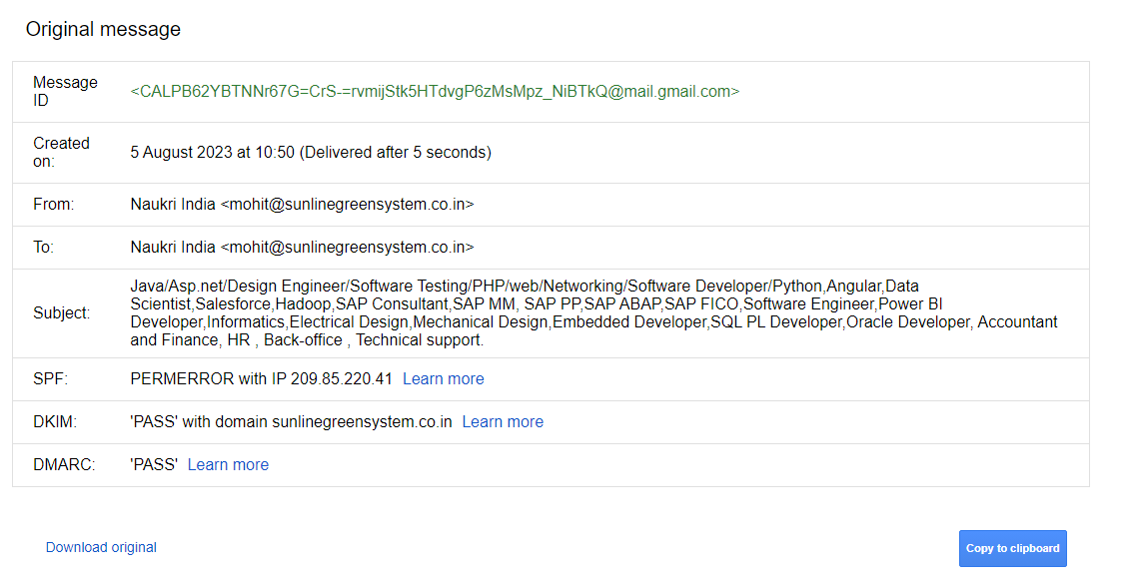

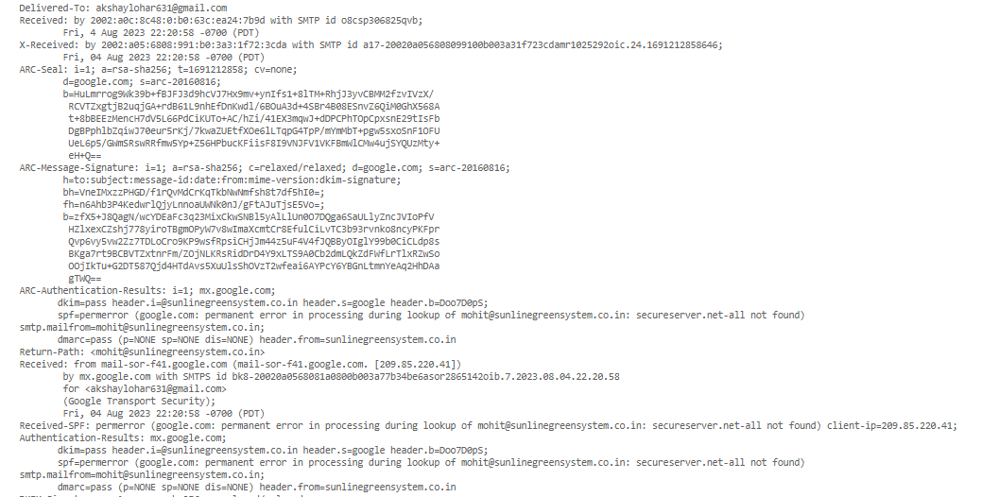

*Email header analysis in Gmail*

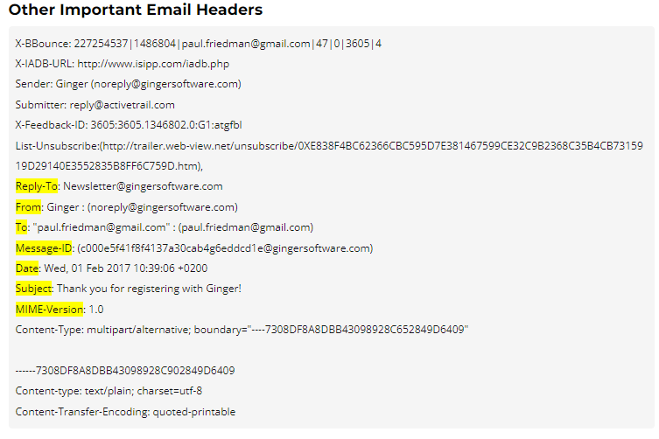

**Email enumeration**

Email enumeration is a type of brute-force attack in which a malicious actor attempts to guess or confirm users in a system by passing an email address to the API and checking the response.

In the examples that follow, email enumeration protection is disabled. Identity Platform returns information that can be used in an email enumeration attack:

* An attempt is made to sign in with an email address that doesn't exist in the system. Identity Platform returns an EMAIL_NOT_FOUND error.
* An attempt is made to sign up with an email address that already exists in the system. Identity Platform returns an EMAIL_EXISTS error.
* You can use Identity Platform's email enumeration protection feature to protect user accounts in your app from these attacks. Email enumeration protection offers the following features:
* Invalid sign-in cases return an INVALID_LOGIN_CREDENTIALS error response. Invalid sign-up cases return EMAIL_EXISTS.
* Removes error responses for email verification flows. If the email address exists, a verification email is sent. If it does not exist, a verification email is not sent. We recommend that you do not allow users to sign up without an email verification flow.
* Disables the ability for users to change their email address without first verifying the new address.
* Disables listing of sign-in methods for a specified email address when calling createAuthUri.

**Step #1: Getting Started with theHarvester**

* The first step is to download the Harvester. If you are using a Linux distribution other than Kali, you can get theHarvester from github.com such as;
* kali > git clone https://github.com/laramies/theHarvester
* If you are using Kali, it is built into nearly every version. If not, simply download it from the repository. Note the lower case "h" in the repository name.
* kali > sudo apt install theharvester

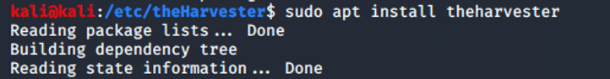

**Step #2: the Harvest Syntax and help**

* Let's begin by examining the help screen for the Harvester.
* kali > theHarvester -h

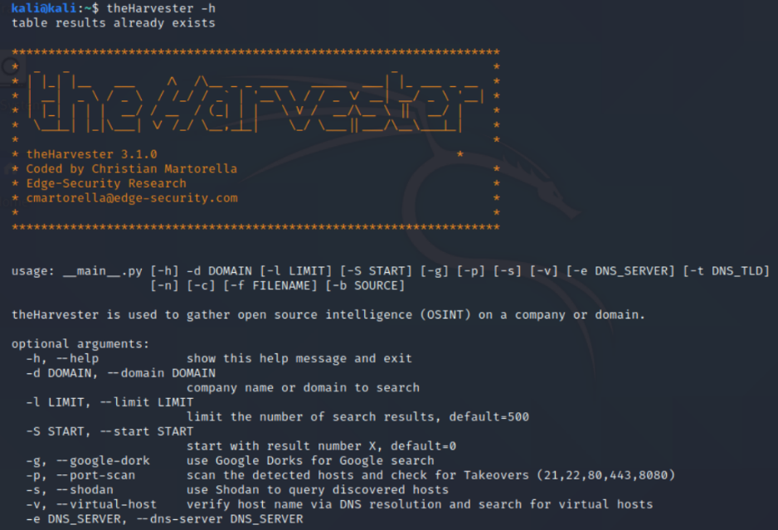

theHarvester -d <domain>

We can specify which source we want to access for data by using the -b switch, such as;

1. Baidu
2. Bing
3. Bing API
4. Certspotter
5. CRTSH
6. DNSdumpster
7. Dogpile

and many others. If you want to use all these resources, you can simply use the all switch from the command line.

In some cases, you will want to use the services API (application programming interface). To do so, open the text file in any text editor at /etc/theHarvester/api-kets.yaml like below.

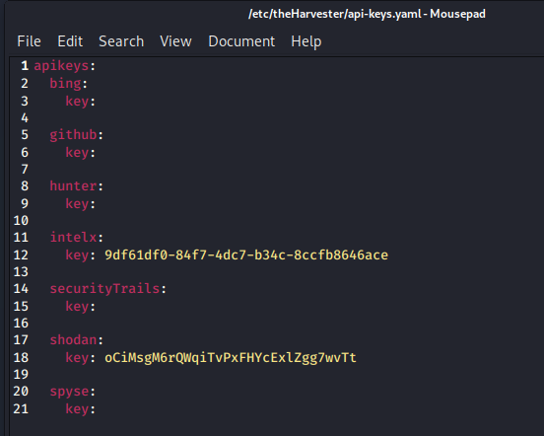

**Step #3: Run a Scan with theHarvester**

Now, let try using theHarvester against everyone's favorite electric car manufacturer, Tesla. To scrape all this data on Tesla, we can use the following command;

kali > theHarvester -d teslas.com -b all -f /home/kali/tesla_results2

Where:

theHarvester is the command

-d tesla.com directs the tool to scape data from the domain (-d) tesla.com

-b all directs this tool to use all the sources available

-f /home/kali/tesla_results2 directs the tool to send the results to file

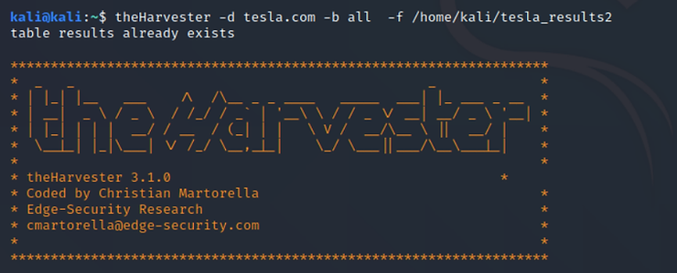

When the Harvester completes its work, we can view the results by opening the tesla_results2 file to view with a web browser.

kali > firefox tesla_results2

This opens our HTML file as seen below.

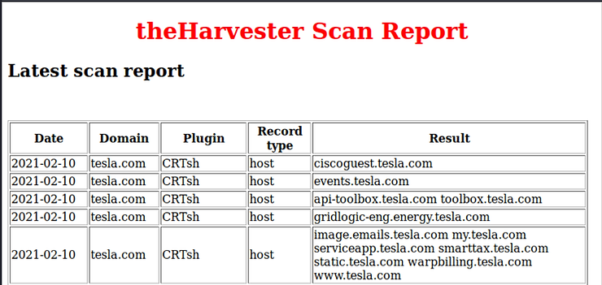

If we scan down a bit, we can see that theHarvester has scraped numerous emails from Bing and other search engines.

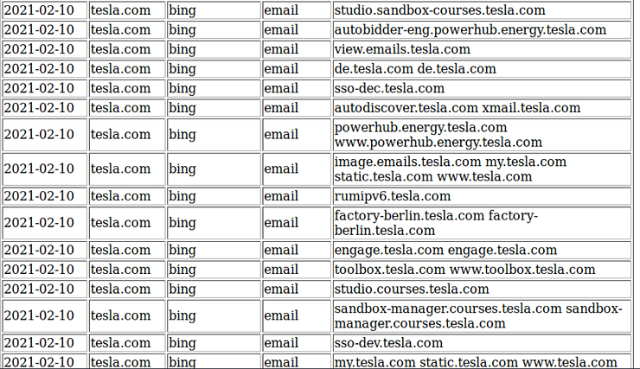

⚫ **Conclusion:**

Perform Email Header Analysis for extracting valuable information like sender IP address, email Use tools like the Harvester or thehunter.io to search for email addresses associated with a IP address, email's origin, potential geographic location of the sender, or possible email routing.

**EXPERMINT: 02**

⚫ **Aim:** Using OSINT tool such as (Harverster) you can gather information like emails, subdomains, hosts, employee names, open ports and banners from different public sources like search engines, PGP key server.

⚫ **Theory:**

**TheHarvester**

theHarvester is an open-source OSINT (Open-Source Intelligence) tool used for gathering information about email addresses, subdomains, hosts, employee names, open ports, and more from various public sources like search engines, PGP key servers, and social media sites. It is primarily used for reconnaissance and information gathering in the field of cybersecurity and penetration testing.

**Here's a breakdown of the key features and uses of theHarvester:**

* **Email Enumeration**: theHarvester can be used to search for email addresses associated with a specific domain. This is useful for identifying valid email addresses within an organization, which can be valuable for security assessments.
* **Subdomain Discovery**: It can discover subdomains associated with a target domain. This information can be helpful for understanding a target's web infrastructure and potential attack surfaces.
* **Host Discovery**: theHarvester can find information about hosts and servers associated with a domain, helping in network reconnaissance and vulnerability assessments.
* **Employee Name Gathering**: It can assist in finding employee names associated with a target domain, which can be valuable for social engineering or profiling.
* **Open Port Scanning:** theHarvester can check for open ports on the discovered hosts, which can be important for identifying potential entry points for a penetration test.
* **Integration with Multiple Data Sources**: theHarvester supports integration with various data sources such as search engines (Google, Bing), PGP key servers, and social media platforms. This provides a broad range of information sources for reconnaissance.
* **Customizable and Extensible**: Users can customize theHarvester's search parameters to tailor it to their specific needs. It is also extensible, allowing you to add your data sources and plugins.

**How to install theHarvester:**

1 If you are using a Kali Linux machine then this tool is already installed in it, just type the command

theharvester

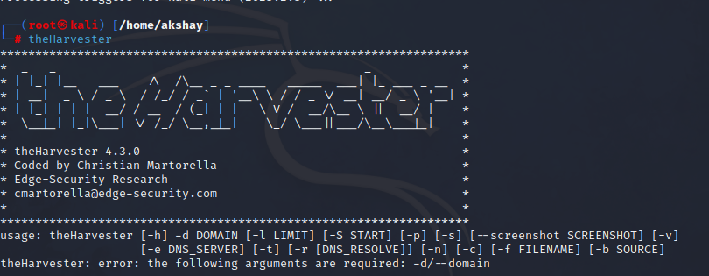

use theharvester tool feature by giving a domain name in the command python3

theHarvester.py -d -l 500 -b

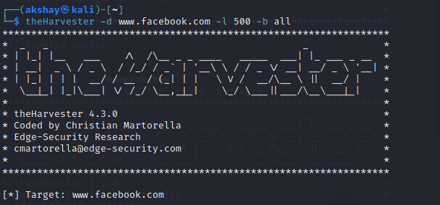

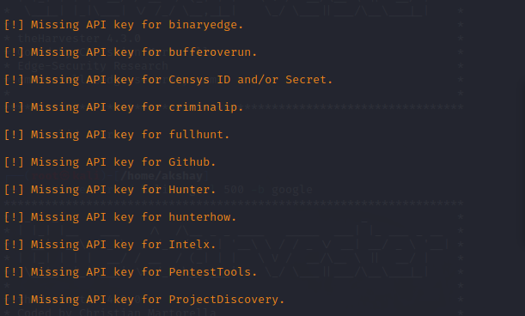

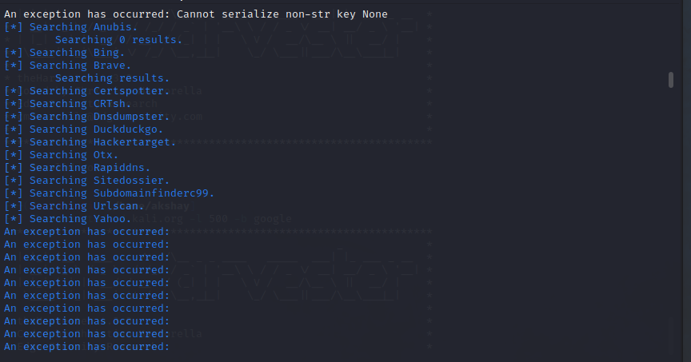



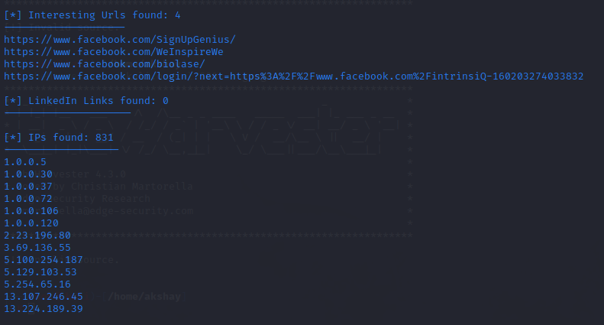

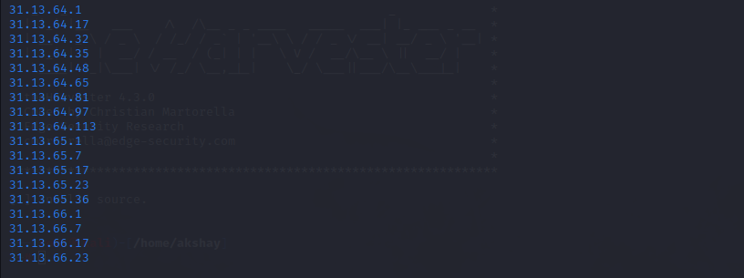

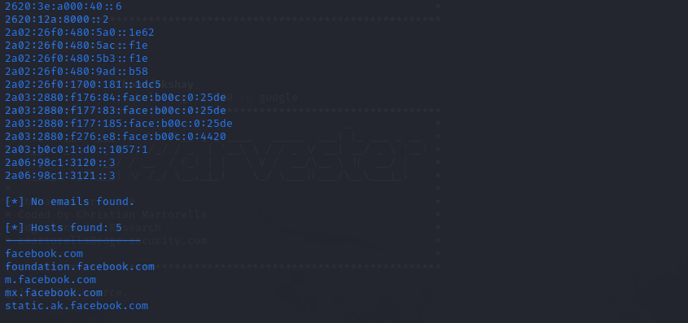



⚫ **Conclusion:**

Using OSINT tools like theHarvester, you can effectively gather a wide range of information from public sources, including emails, subdomains, hosts, employee names, open ports, and banners. This information can be invaluable for various purposes such as reconnaissance, security assessments, and penetration testing. However, it's essential to use these tools responsibly, following legal and ethical guidelines, and ensuring that your activities are conducted within the bounds of the law.

**EXPERMINT: 03**

⚫ **Aim:** Use OSINT DORKS (create and execute search queries) to verify the accuracy of the information by cross-referencing various sources and critically evaluating the reliability and credibility of the new article.

⚫ **Theory:**

**Google Dorks for OSINT Investigations**

Dorking is a technique that uses advanced search operators within Google Search and other search engines to find information. Primarily used to locate security holes in the configuration and computer code within websites, Dorks can also provide investigators with opportunities to enhance intelligence gathering during OSINT investigations.

Advanced search operators are special commands within search engines that modify searches by adding parameters to narrow searches and drill deeper into results.

We’ve outlined 14 advanced search operators that can be useful to investigators to refine search results, which include:

* **“**search term**”**= exact phrase, i.e. [**"**Skopenow streamlines your due diligence and claims process**"**](https://www.google.com/search?q=%22Skopenow+streamlines+your+due+diligence+and+claims+process%22)

Quotation marks enable users to force an exact match for required words or phrases. The exact match operator can be used to refine results to ensure that a specific phrase is included in the results or to exclude synonyms when searching for single words. Searching for an exact phrase during an investigation can locate material written by a specific person or business.

* **OR** or **|** = ***either*** search term ***or*** search term, i.e. [Ed **OR** Edward](https://www.google.com/search?q=Ed+OR+Edward) or [Ed](https://www.google.com/search?q=Ed%7CEdward%7CEdwin)**[|](https://www.google.com/search?q=Ed%7CEdward%7CEdwin)**[Edward](https://www.google.com/search?q=Ed%7CEdward%7CEdwin)**[|](https://www.google.com/search?q=Ed%7CEdward%7CEdwin)**[Edwin](https://www.google.com/search?q=Ed%7CEdward%7CEdwin)

The OR operator enables searching for multiple words as alternatives to one another, locating either X or Y or both. The pipe (|) operator functions identically to “OR”. Investigators can utilize the OR operator when only a nickname is known for a subject, enabling different variations of the same name to be searched at once.

* **+**or **AND** = search term ***and*** search term, i.e. [Steve Adams **AND** Skopenow](https://www.google.com/search?q=Steve+Adams+AND+Skopenow)

The AND operator enables searching for results that must include two different words phrases, searching for both X and Y. Results will only include results that include both search phrases. The plus (+) operator can also be used in place of “AND”. AND can be useful for investigators when searching for information on a person, ensuring results relate to them by including their employer’s name.

* **-**= Not search term, i.e. [Skopenow](https://www.google.com/search?q=Skopenow+-www.skopenow.com&)**[-](https://www.google.com/search?q=Skopenow+-www.skopenow.com&)**[www.skopenow.com](https://www.google.com/search?q=Skopenow+-www.skopenow.com&)

The minus operator enables users to exclude a word or phrase from search results. When results are extensive, removing irrelevant words that feature prominently in numerous results is particularly useful when looking to reduce results.

* **site:** = Only on this site, i.e. [“Skopenow” **site:**twitter.com](https://www.google.com/search?q=%E2%80%9CSkopenow%E2%80%9D+site%3Atwitter.com)

The site operator enables users to restrict results to only those from a specific website. When investigating a business, the site operator can ensure results come specifically from their official website.

* **filetype:** = Only this type of file, i.e. [OSINT **filetype:**pdf OR **filetype:**docx](https://www.google.com/search?q=OSINT+filetype%3Apdf+OR+filetype%3Adocx)

The filetype operator enables search results to be restricted to those that are a specific file type, removing other file types and standard web pages. filetype: can provide benefit during an investigation when searching for contracts and whitepapers in PDF or Word documents.

* **intitle:** = Only show results where text is in title of site, i.e. **[intitle:](https://www.google.com/search?q=intitle%3Afinal.attendee.list+%22Fraud%22)**[final.attendee.list "Fraud"](https://www.google.com/search?q=intitle%3Afinal.attendee.list+%22Fraud%22)

The intitle operator enables users to find web pages with a certain word or phrase in the title. Investigators can use the intitle operator to find relevant web pages and articles containing a relevant keyword.

* **inurl:** = Only show results where text is in the web address of a website, i.e. **[inurl:](https://www.google.com/search?q=inurl%3Aresume+%E2%80%9Cjohn+smith%E2%80%9D)**[resume “john smith”](https://www.google.com/search?q=inurl%3Aresume+%E2%80%9Cjohn+smith%E2%80%9D)

The inurl operator enables users to find web pages with a certain word or phrase in the web address. Investigators can use the inurl operator to find relevant web pages containing a keyword in the web address.

* **intext:** = Only show results where text is in the main body of the text of a website, i.e. [Skopenow](https://www.google.com/search?q=Skopenow+intext%3AOSINT)**[intext:](https://www.google.com/search?q=Skopenow+intext%3AOSINT)**[OSINT](https://www.google.com/search?q=Skopenow+intext%3AOSINT)

The intext operator enables users to find web pages with a certain word or phrase in the main text of the web page. Investigators can use the intext operator to locate results where a keyword within the body of a web page will limit results, such as a year or location name.

* **allintext:** = locate all words in a web page, i.e. **[allintext:](https://www.google.com/search?q=allintext%3A+skopenow+insurance+fraud)**[skopenow insurance fraud](https://www.google.com/search?q=allintext%3A+skopenow+insurance+fraud)

The allintext operator enables users to find web pages that contain a list of keywords in the main text of the web page but not necessarily next to one another. Investigators can use the allintext operator when more than one keyword is necessary as an anchor within the body of a webpage to find results, such as multiple keywords or names related to a crime.

* **cache:** = Only show cached links, i.e. [**cache:**skopenow.com](https://webcache.googleusercontent.com/search?q=cache%3Askopenow.com)

The cache operator enables users to return the most recently cached version of a webpage when the web page has been indexed. Investigators can use the cache operator to locate previous versions of edited or deleted web pages to locate removed intelligence.

* **\***= wildcard, i.e. ["robdouglas**\***com"](https://www.google.com/search?q=%22robdouglas*com%22)

The asterisk operator represents a wildcard within search strings, taking the place of words or phrases between two keywords. Investigators can use the asterisk operator to find email addresses by replacing the domain name with the wildcard character.

* **map:**= map a specific location, i.e. [**map:**Manhattan](https://www.google.com/search?q=map%3A+Manhattan)

The map operator enables users to force Google to show map results for a locational search. The results show only location-specific data and do not include recent news stories. Investigators can use the map operator to focus on geospatial relevant intelligence.

Skopenow augments investigations by instantly building comprehensive, court-ready, digital reports on businesses and individuals. Skopenow collects, collates, and analyzes information from data sources, including social media, the dark web, associated vehicles, court records, and contact data.

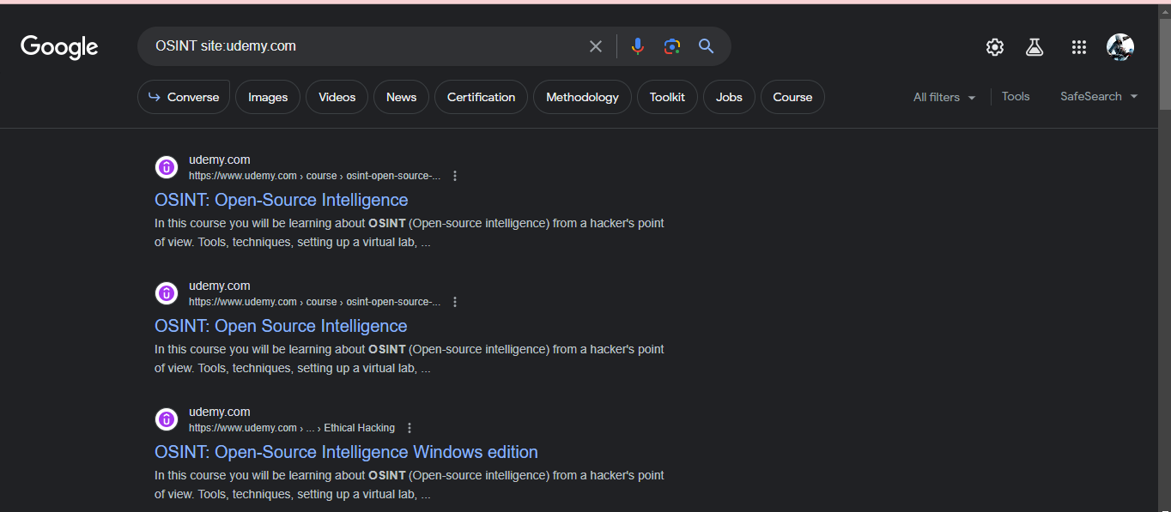

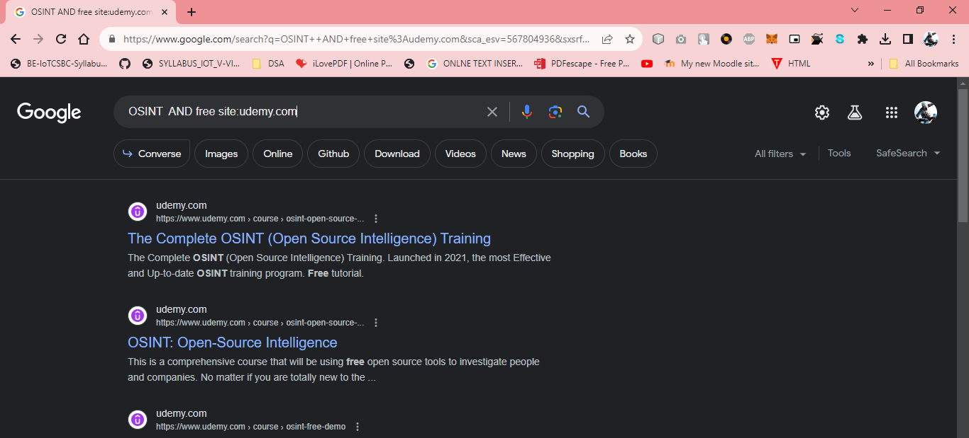

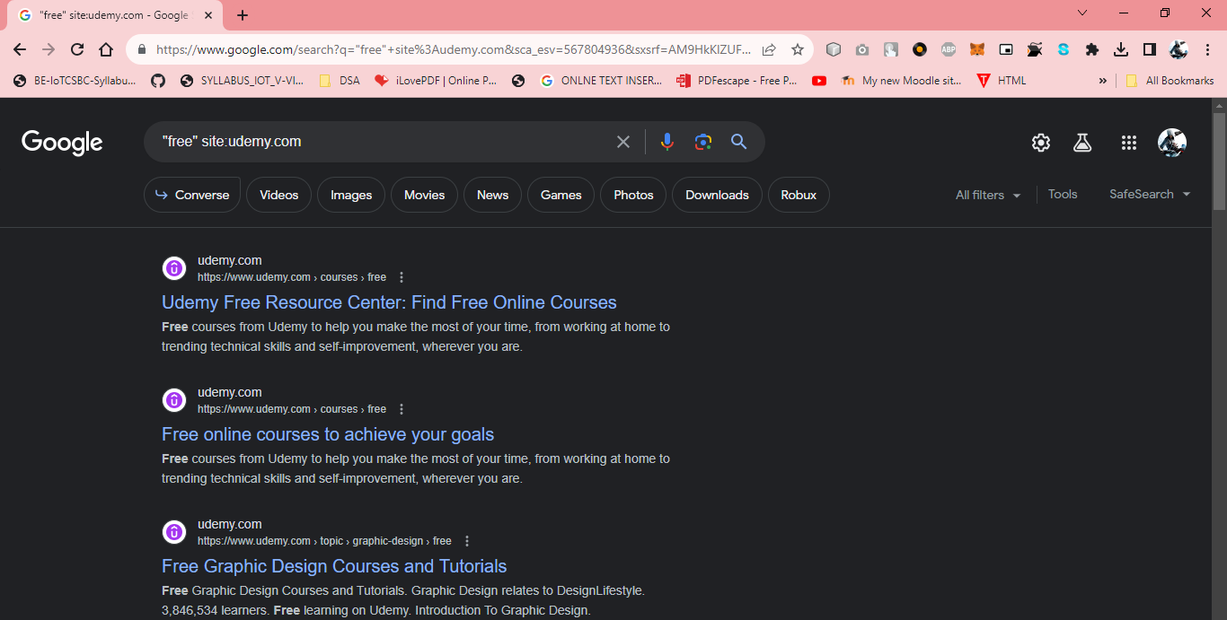

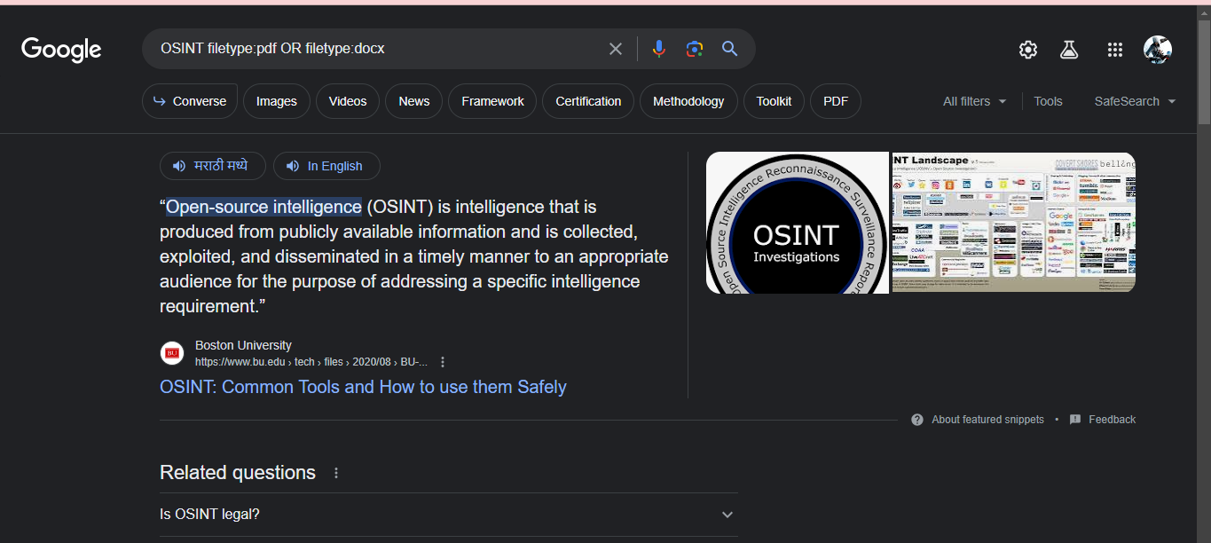

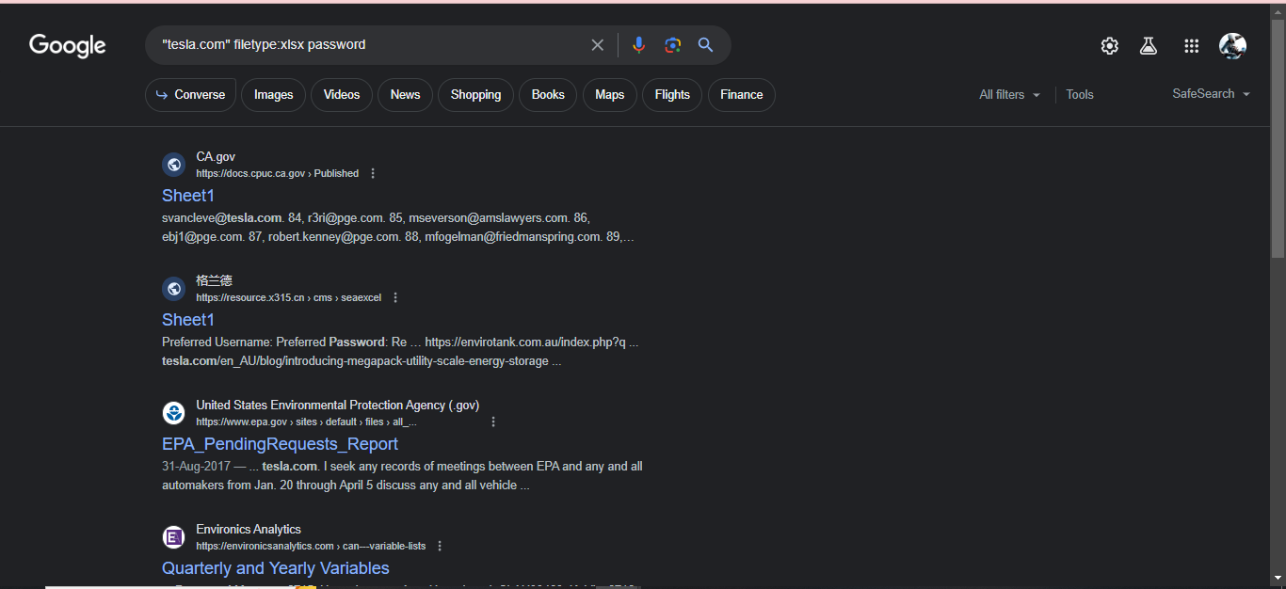

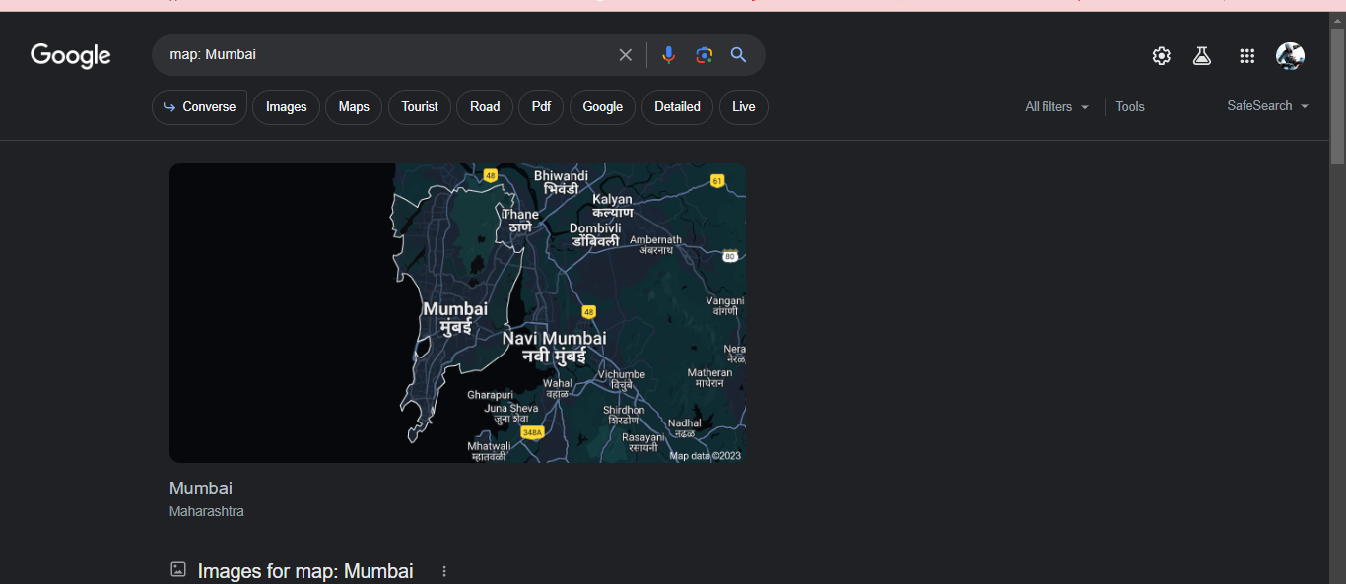

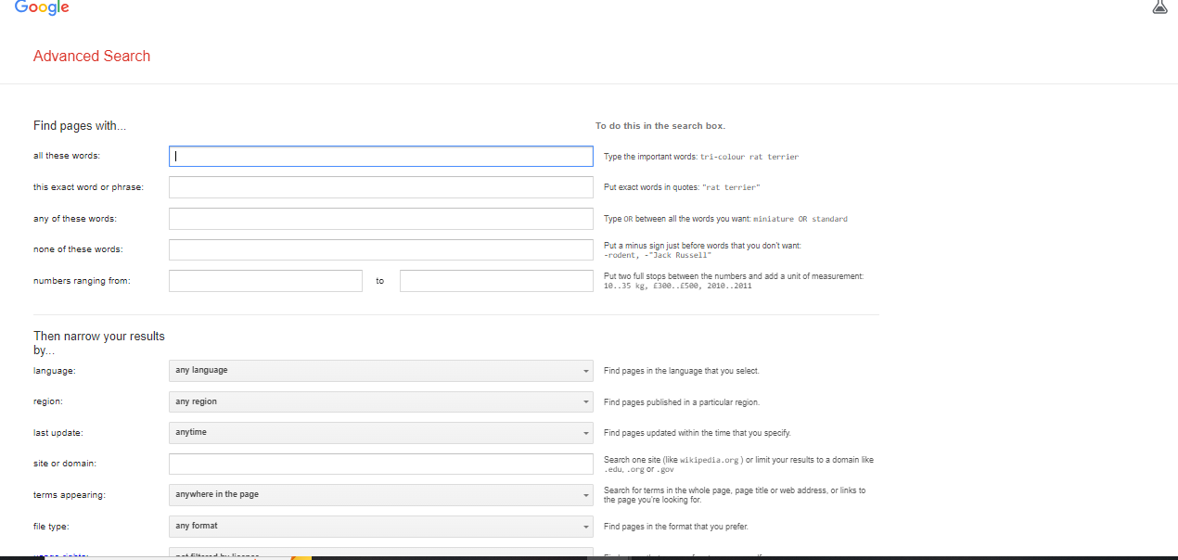

⚫ **Conclusion:**

By using OSINT dorks and cross-referencing information from multiple sources, you can critically evaluate the accuracy and reliability of news articles. This approach can help you make more informed judgments about the information you come across online.

**EXPERMINT: 04**

⚫ **Aim:** To perform the reverse Image analysis for finding physical location where the content was captured. Use OSINT tool to use image metadata, landmarks, street signs, or other visual cues to identify the geolocation accurately.

⚫ **Theory:**

Images can provide a wealth of value to an OSINT investigation, they can show what a subject looks like, locations where the subject has been, and any vehicles used. Identifying this information can facilitate actions like surveillance or arrests, which would otherwise be reliant on text-based descriptions.

Using search engines and free tools, investigators can utilize images to develop the intelligence picture, identify devices used to take images, identify where and when images were taken, and identify if a social media account belongs to a subject.

This article will detail reverse image searching, facial comparison, deepfakes, and metadata, showing you how to get the most value from your image-based OSINT investigations.

**Reverse Image Searching**

Using Search Engines, you can quickly discover visually similar photos from around the web using Reverse Image Searching technology, utilizing content-based image retrieval (CBIR) query techniques. Uploading a photograph from your device or inputting the URL of an image, you can ask a search engine to locate and show you related images used on other websites, either those images that are exactly the same or the same but a different size, or those that contain similar looking items or people.

Reverse Image Searching can be used as part of an investigation to identify related images relating to images that contain statues, buildings, places, people, and logos. Using Search Engines, you may be able to identify where an image was taken by recognizing a statue or building in the background that can be identified by the Search Engine. Similarly, Search Engines may be able to locate other images of your subject or logos on sites that identify them

Some of the best sites for Reverse Image Searching include:

**the reverse Image analysis:**

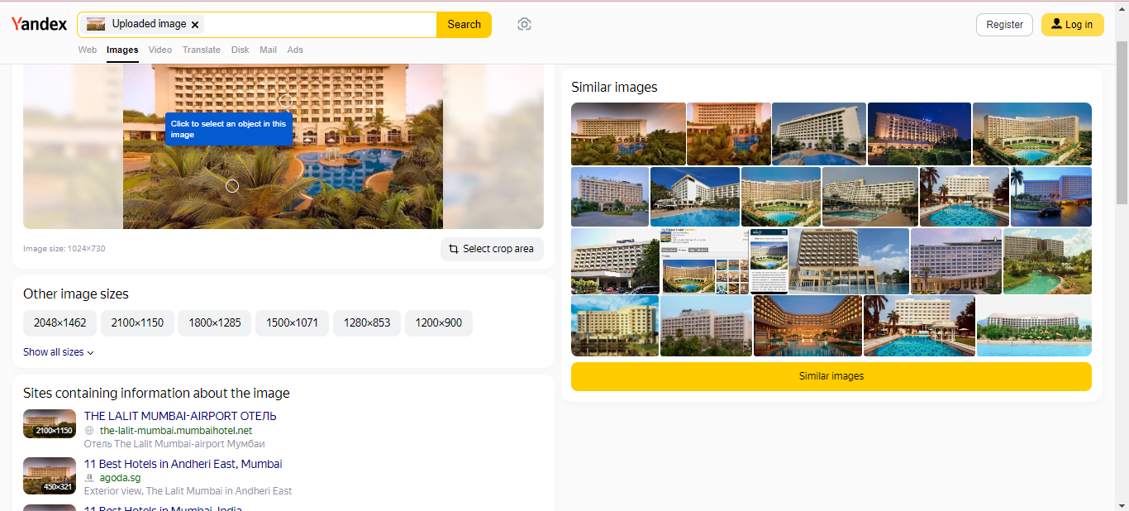

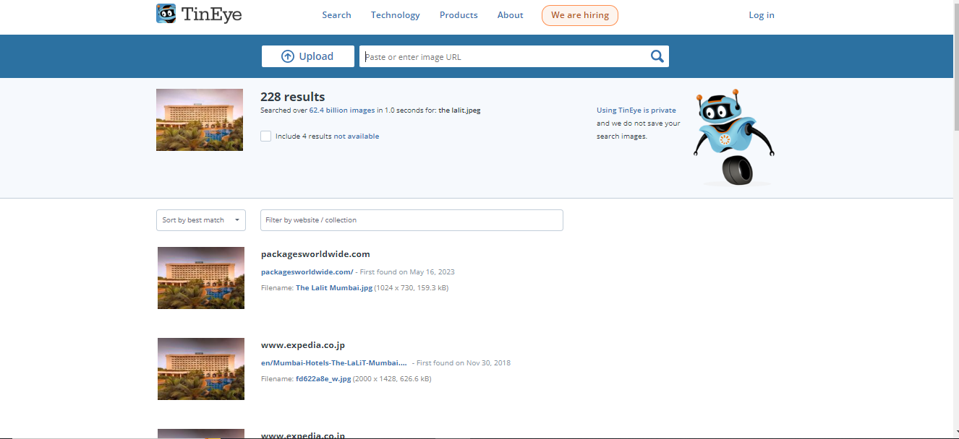





⚫ **Conclusion:**

The reverse image analysis for geolocation is a powerful OSINT technique that can be a valuable asset for researchers, investigators, and those concerned with the origin and credibility of digital imagery. It is a useful tool for enhancing the verification and contextual understanding of visual content.

**EXPERMINT: 05**

⚫ **Aim:** Using OSINT tools gather Tactical information using WHOIS lookup tools or websites like DomainTools (domain, registration details, owner's contact information, registration date, and expiration date.) Archives, Text, Reverse Image Search, Images and EXIF data, Source code, Others TLD, Mentions of target, Check info such as via RSS,SSL certificates, Robots/Sitemap, Port scans, Reverse IP lookup

⚫ **Theory:**

Analyzing Network Traffic and Data Flow: Network analysis involves studying data traffic patterns to understand connections and behavior:

* **Traffic Analysis**: Monitoring and analyzing network traffic to identify communication patterns and anomalies.
* **Packet Inspection**: Examining individual data packets to gather insights into the type of information being transmitted.
* **Flow Data**: Collecting flow data (e.g., NetFlow) for understanding communication between devices.
* **DNS Lookups** and **WHOIS Queries**: DNS and WHOIS queries reveal information about domains and IP addresses:
* **DNS Analysis**: Investigating domain names and IP addresses to uncover relationships, affiliations, and potential threats.
* **WHOIS Queries**: Querying WHOIS databases to identify domain registrants and contact information.
* **Tracing Network Paths and Hops**: Tracing network paths helps understand data routing and potential bottlenecks:
* **Traceroute**: Tracing the path that data packets take across networks, revealing intermediate devices (hops) and latency.
* **Geolocation of IPs**: Mapping IP addresses to geographical locations aids in understanding network topology.
* **Identifying Online Infrastructure Patterns**: Analyzing online infrastructure patterns involves recognizing common components and their interconnections:
* **Domain Infrastructure**: Identifying domains, subdomains, and their relationships can reveal malicious or suspicious activities.
* **CDN and Cloud Services:** Recognizing the use of content delivery networks and cloud services helps understand a target’s online presence.

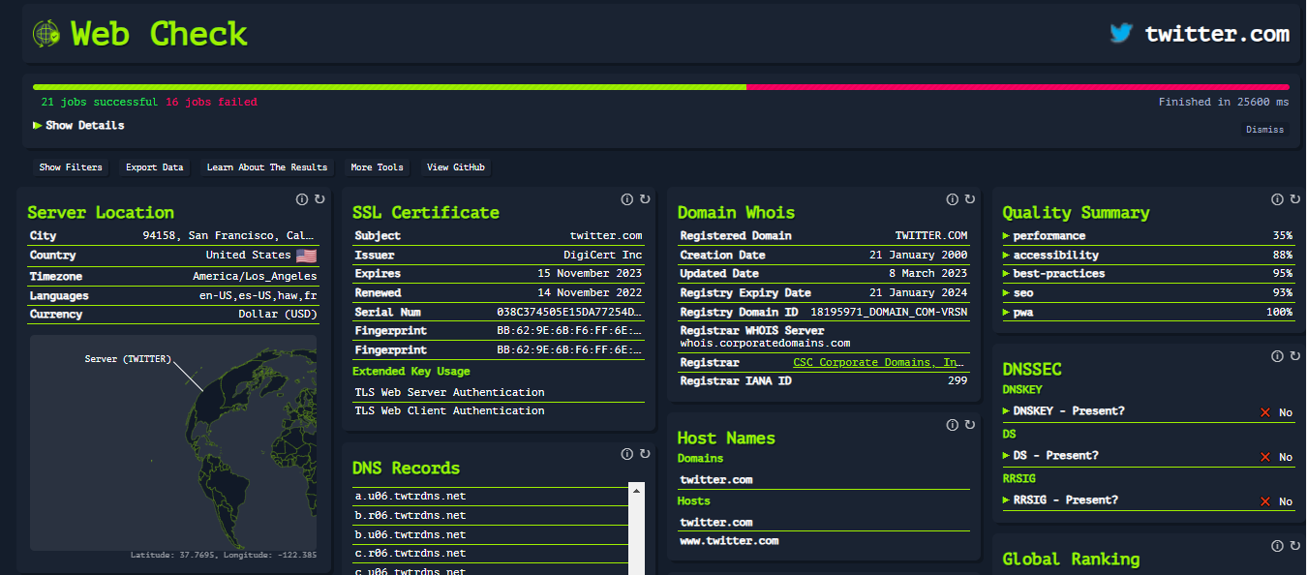

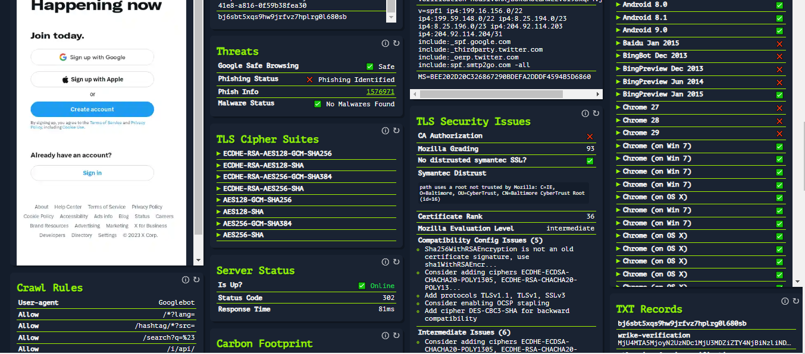

**Sitemap**

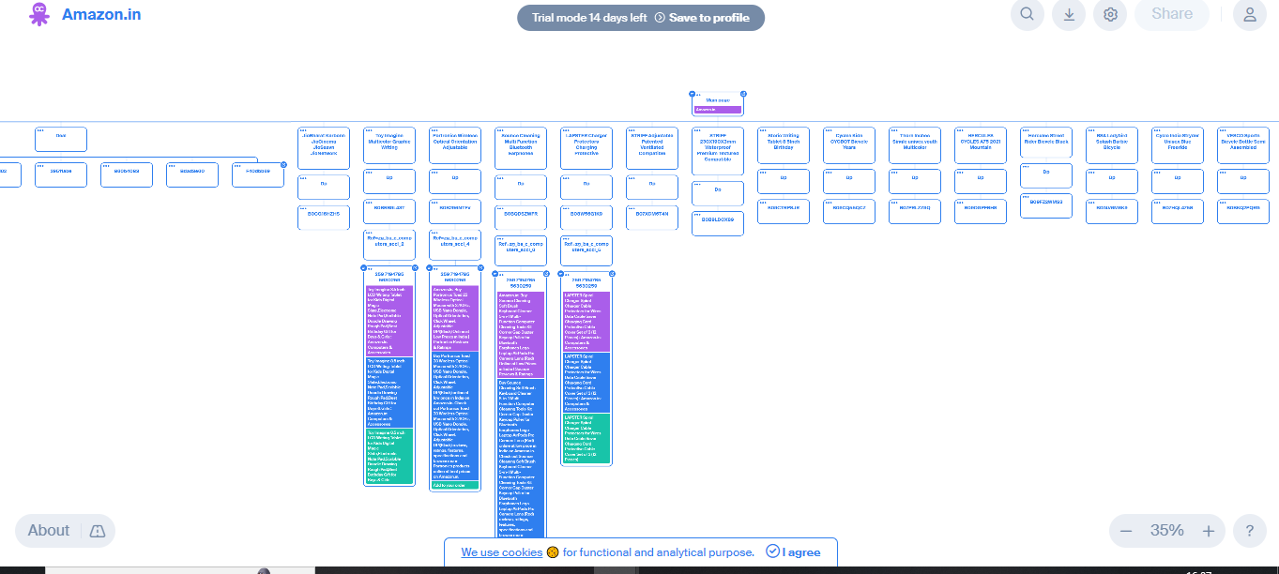

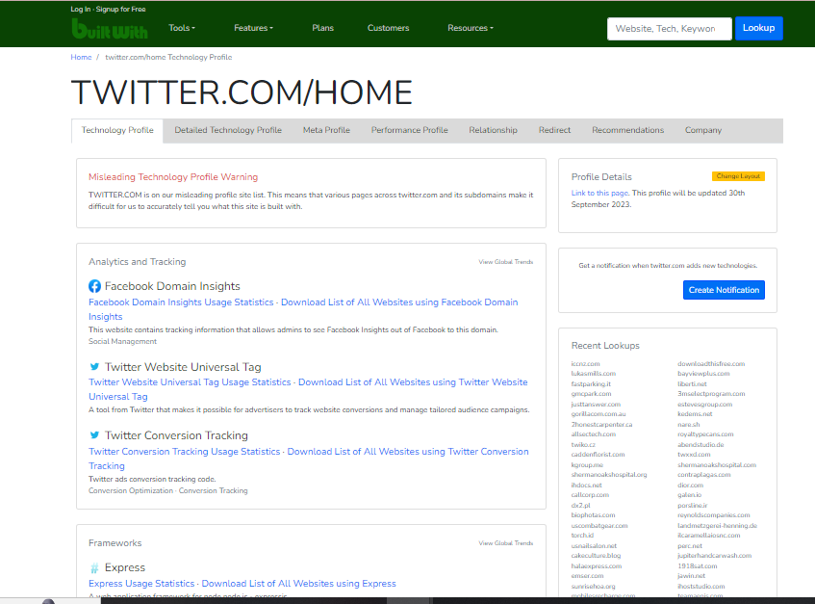

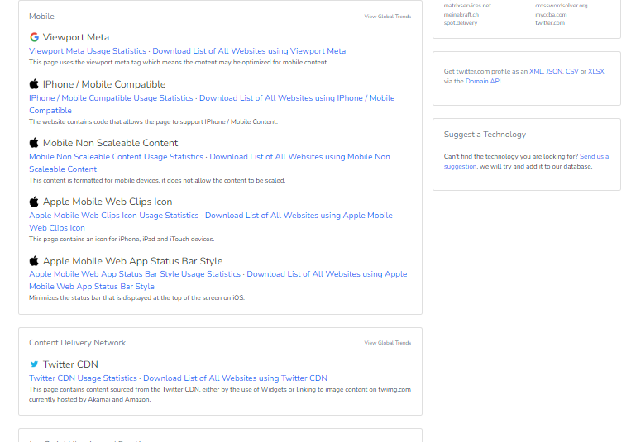

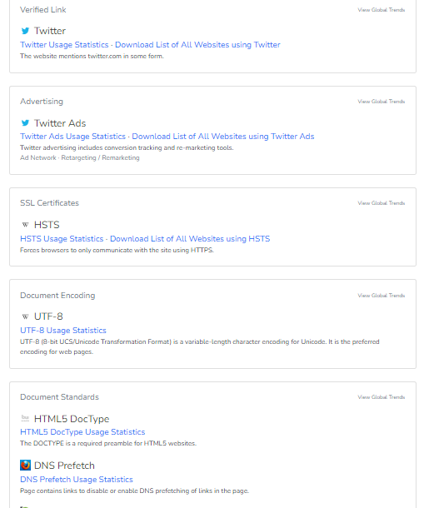

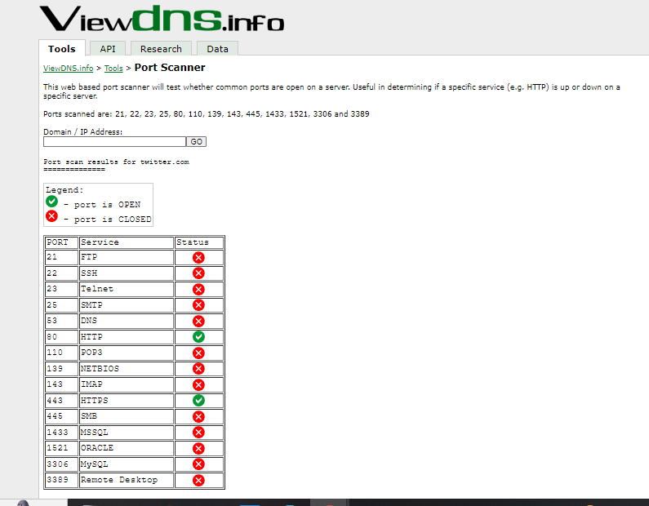

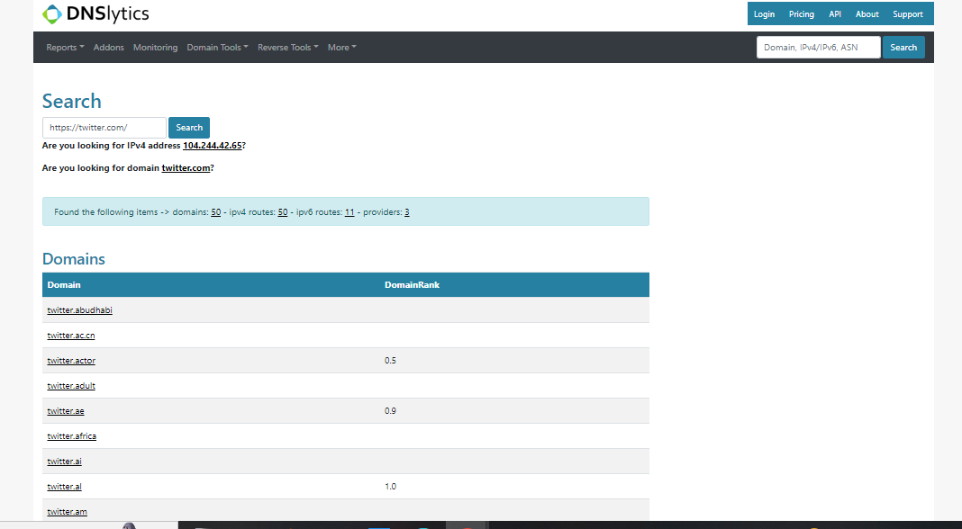

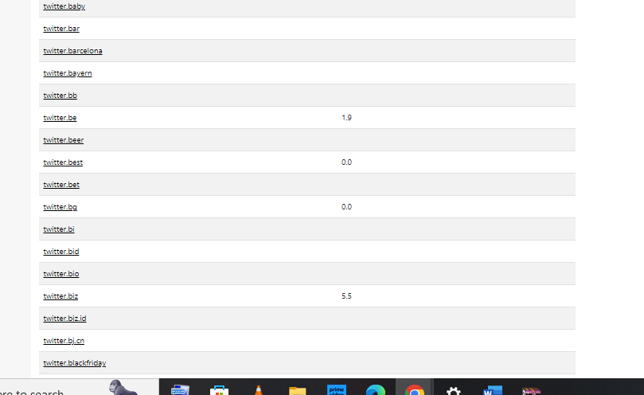

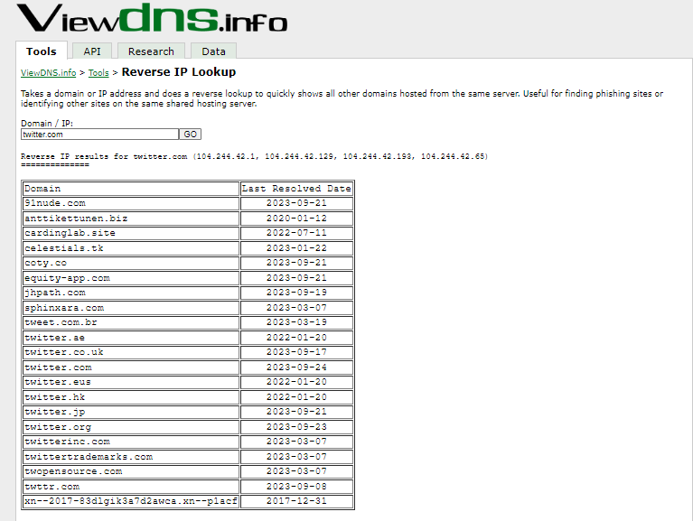

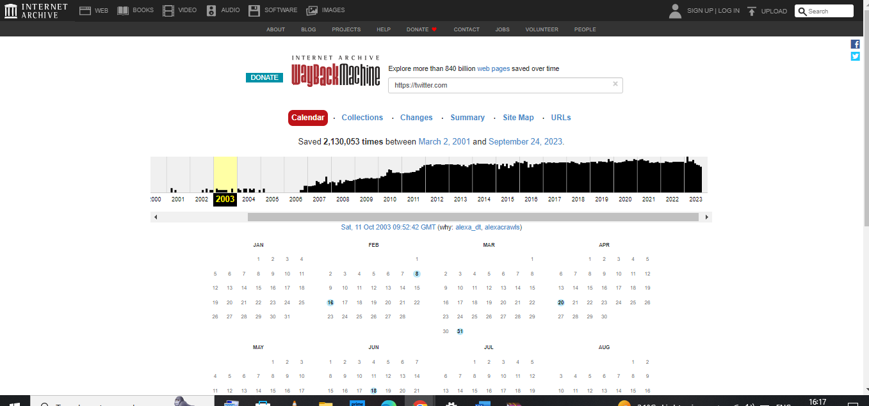

**EXIF DATA WITH IMAGE**

**Metadata**

Metadata is data that provides information about data that is not the content of the data itself, i.e. summarising basic information about data to make it easier to find or work with.

Unfortunately, the majority of social media sites remove metadata from images as they are uploaded, however, if an original digital photo can be sourced then it is likely to provide some information on the photograph. Metadata can be viewed freely using a number of tools.

**Jeffrey's Image Metadata Viewer** — <http://exif.regex.info/exif.cgi>

Jeffrey's Image Metadata Viewer is a browser-based tool that enables you to upload a photo and view the EXIF data, detailing the time and date the image was taken, the type of camera used, and the location (in the event that location was enabled on the camera).

Jeffrey's Image Metadata Viewer will show all of the Metadata within an image, including Camera, Shutter Speed, Date Captured, and any embedded co-ordinates

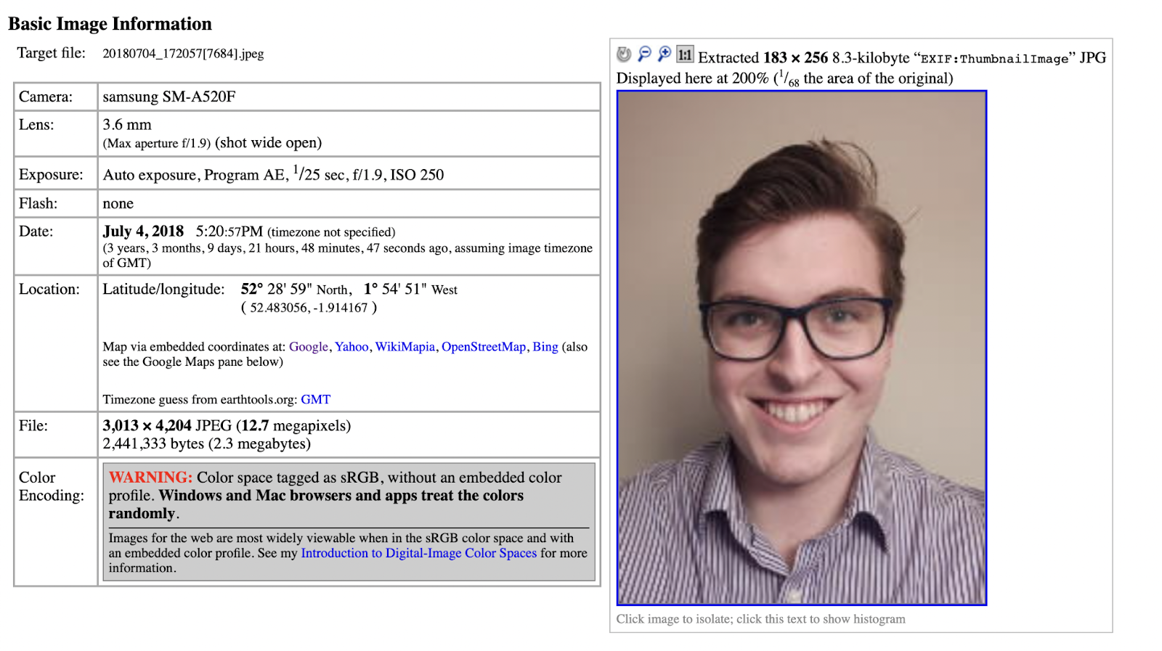

⚫ **Conclusion:**

The collection of tactical information using OSINT tools and techniques is a crucial part of cybersecurity, threat intelligence, and information gathering for various purposes. However, it's essential to use these tools and methodologies responsibly and ethically, respecting privacy and adhering to legal and ethical standards while conducting OSINT activities.

**EXPERMINT: 06**

⚫ **Aim:** Utilize website crawling OSINT tools to gather a comprehensive list of URLs, internal links, and structure of the website.

⚫ **Theory:**

Website crawling, often referred to as web crawling or web scraping, is the automated process of systematically navigating and collecting data from websites. It involves accessing web pages, extracting information, and following links to other pages within the website. Website crawling is a common practice used for various purposes, including data collection, content indexing, SEO analysis, and competitive research.

Here are the key aspects of website crawling:

* **Crawler or Spider**: A program or script, known as a crawler or spider, is used to navigate the web and retrieve data from websites. These crawlers follow predefined rules and instructions to access and interact with web pages.
* **URL Discovery**: Crawlers start with one or more initial URLs, often referred to as "seed" URLs. They use these seed URLs to discover other URLs on the website by analyzing the content and following links.
* **Data Extraction**: Crawlers can extract various types of data from web pages, such as text, images, links, metadata, and more. The specific data to extract is defined in the crawler's instructions.
* **Link Analysis**: Crawlers follow internal links on the website, allowing them to navigate to different pages within the same domain. This helps create a comprehensive map of the site's structure.
* **Respect Robots**.txt: Responsible web crawling involves respecting the rules defined in the website's robots.txt file. This file specifies which parts of the site are off-limits to crawlers.
* **Rate Limiting**: To avoid overloading a website's servers and potentially causing disruption, crawlers may employ rate limiting, ensuring that requests are made at a reasonable pace.
* **Data Storage:** Data collected during web crawling is typically stored in a structured format for further analysis, reporting, or indexing. This data can be saved in databases, spreadsheets, or other storage solutions.
* **Continuous Monitoring**: Web crawling can be set up to run periodically to keep the collected data up to date.

Common use cases for website crawling include:

* **Search engine indexing**: Search engines like Google use web crawlers to index and rank web pages.
* **Data scraping:** Extracting data from websites for various purposes, such as competitive analysis, price comparison, or content aggregation.
* **SEO analysis**: Crawling a website to assess its SEO performance, including page load times, broken links, and content quality.
* **Content monitoring**: Keeping track of changes to specific web pages or websites.
* **Market research**: Collecting data from e-commerce websites to analyze products, prices, and trends.

**Setting up Scrapy:**

* First, you need to install Scrapy using pip: “pip install scrapy”.
* Once Scrapy is installed, you can create a Scrapy project using the command scrapy startproject project_name.

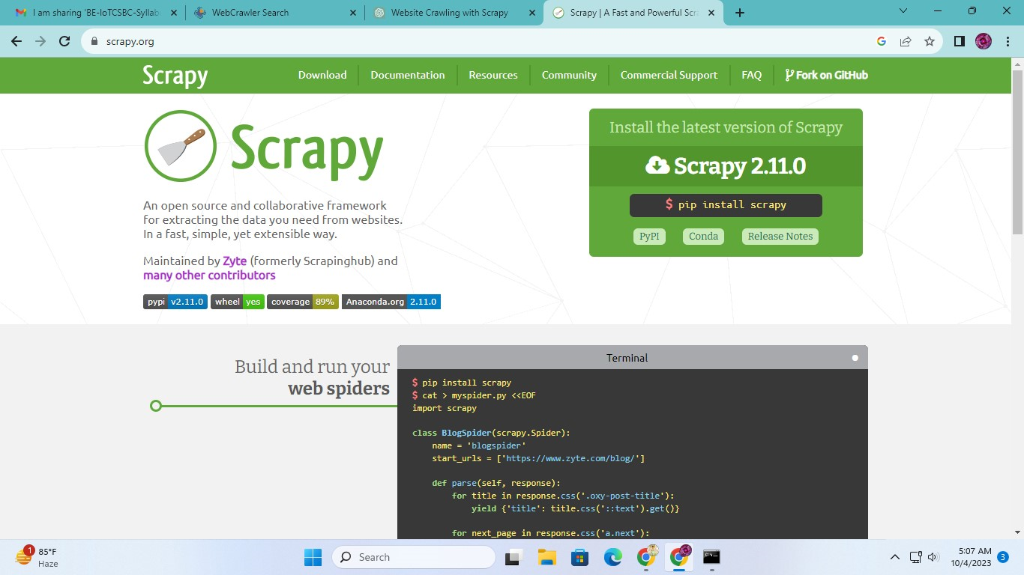

**Defining Spiders:**

* In Scrapy, spiders are custom Python classes that define how to crawl and scrape data from specific websites.
* You create a spider by defining its start URLs and rules for following links.
* You can use the scrapy genspider command to generate a new spider for a particular domain.

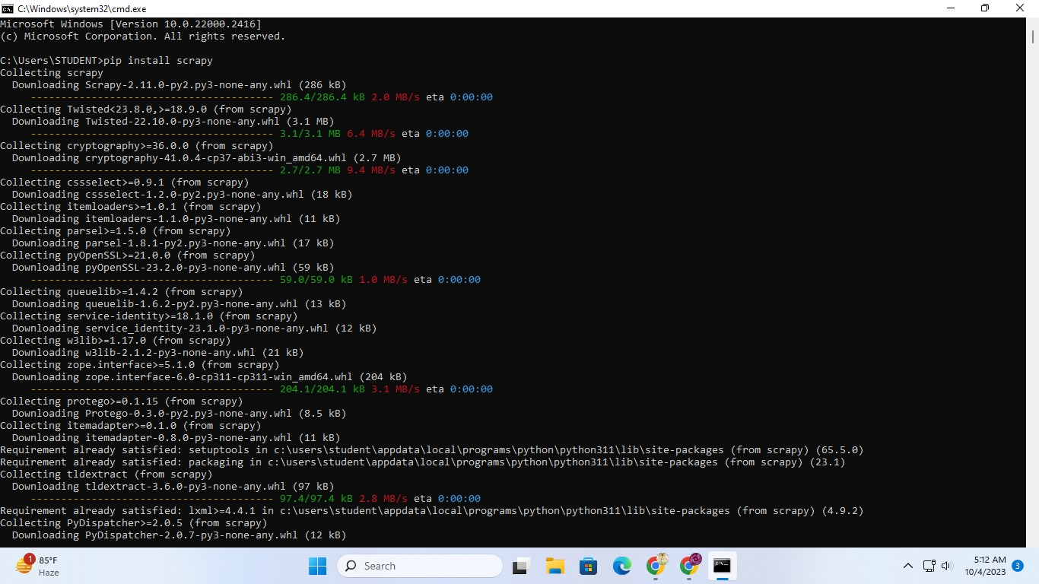

**Spider Logic:**

* In your spider, you override the start_requests method to specify the initial URLs to crawl.
* You define parsing methods that extract data from the downloaded web pages. These methods typically use XPath or CSS selectors to locate and extract data from the HTML.
* You may also define rules for following links to other pages on the website.

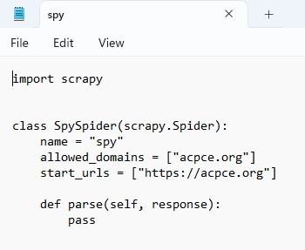

**Sending Requests:**

* Scrapy sends HTTP requests to the URLs specified in the start_requests method or discovered during crawling.
* You can customize requests by setting headers, cookies, and other parameters.
* Responses from the server are processed by the parsing methods.

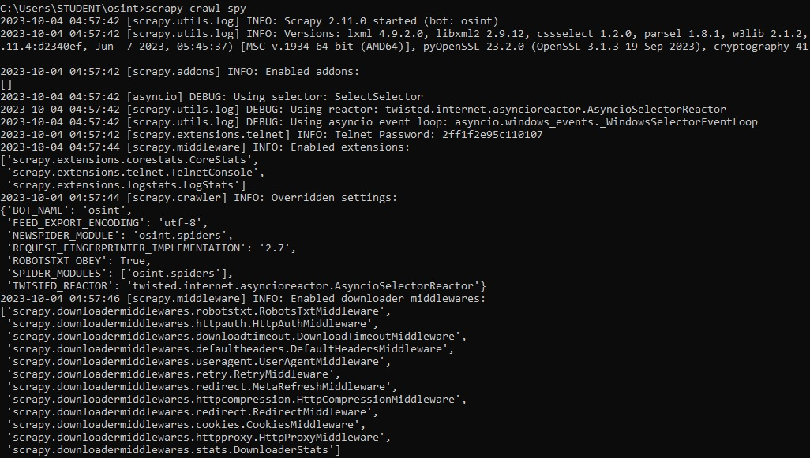

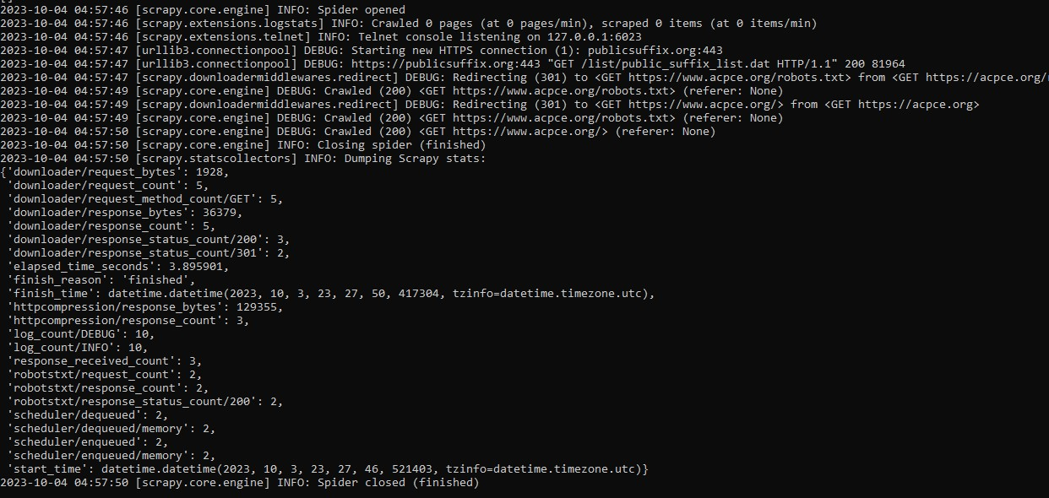

⚫ **Conclusion:**

The use of website crawling OSINT tools is a valuable method for systematically gathering data about a website. This data can be crucial for decision-making in the fields of cybersecurity, digital marketing, and web development. It's important to use these tools responsibly, respect the website's terms of service, and ensure that your web crawling activities comply with legal and ethical guidelines.

**EXPERMINT: 07**

⚫ **Aim:** Use OSINT Tools to identify the technologies and frameworks used by the website, such as content management systems (CMS), server software, programming languages, or analytics tools and create vulnerability reports.

⚫ **Theory:**

There are many OSINT tools to identify the technologies and frameworks used by the website, such as content management systems (CMS), server software, programming languages.

One of them is WHATRUNS. "WhatRuns" is a browser extension designed to help users quickly identify the technologies and frameworks used by websites they visit.

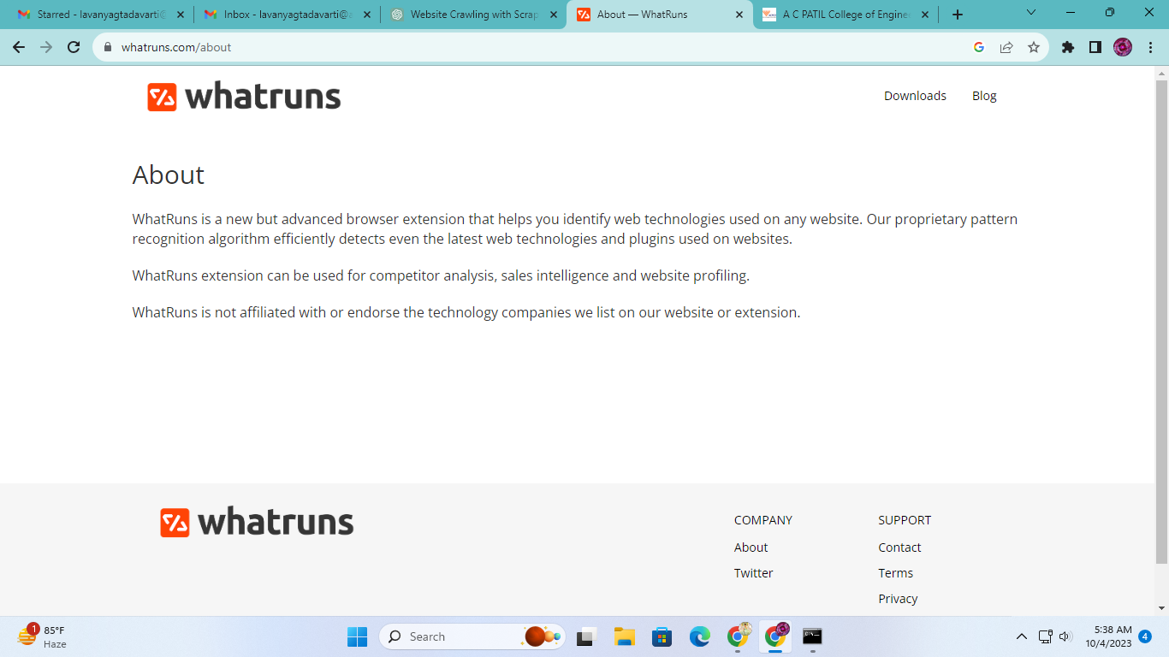

When you visit a website, you can activate the WhatRuns extension by clicking on its icon in your browser's toolbar. Once activated, the extension will scan the webpage and provide a list of technologies and tools that the website is using.

WhatRuns provides detailed information about various aspects of a website's technology stack, including:

* Content Management System (CMS) if applicable (e.g., WordPress, Joomla, Drupal).
* Web server software (e.g., Apache, Nginx).
* JavaScript libraries and frameworks (e.g., jQuery, React, Angular).
* Fonts and typography used on the site.
* Analytics and tracking tools (e.g., Google Analytics).
* CDN (Content Delivery Network) services.
* Advertising and marketing platforms.

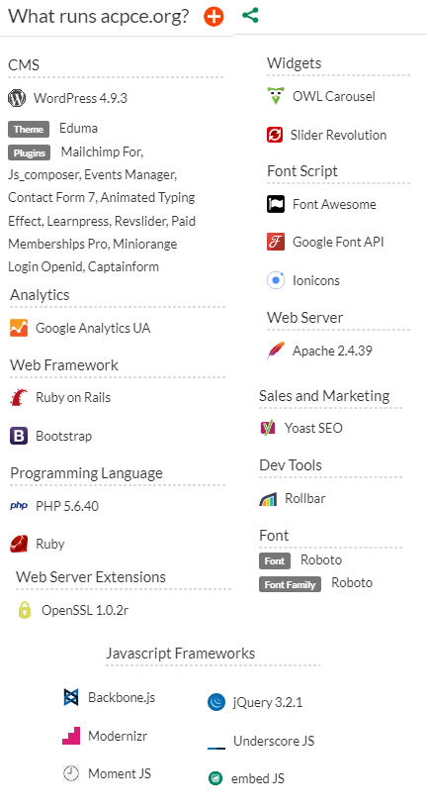

⚫ **Conclusion:**

We have successfully used OSINT Tools to identify the technologies and frameworks used by the website, such as content management systems (CMS), server software, programming languages, or analytics tools and create vulnerability reports.

**EXPERMINT: 08**

⚫ **Aim:** Determine the geolocation (country, city, or approximate location) of each IP address (at least 10) One can use online IP geolocation tools, databases, and various techniques to gather information and accurately identify the physical location associated with each IP.

⚫ **Theory:**

The purpose of finding the exact location of an IP address can vary depending on the situation and the user's intent. Here are some common reasons why someone might want to determine the exact location of an IP address:

1. **Geolocation Services**: Many websites and online services use IP geolocation to provide region-specific content or services. For example, a weather website might use your IP address to show you the weather forecast for your current location.
2. **Security**: Organizations and security professionals use IP geolocation to identify potential threats or suspicious activities. If an IP address is associated with malicious activity, knowing its location can help in taking appropriate security measures.
3. **Content Localization**: E-commerce websites and content providers often use geolocation to tailor content, offers, and advertisements to specific regions or countries. This personalization can improve user experience and increase engagement.
4. **Fraud Prevention**: Banks and online payment processors use IP geolocation to detect potentially fraudulent transactions. If a transaction appears to be coming from an unusual or unexpected location, it may trigger additional security checks.
5. **Network Troubleshooting**: IT professionals may use IP geolocation to troubleshoot network issues. Knowing the location of a problematic IP address can help in diagnosing and resolving network problems more efficiently.
6. **Compliance**: Some industries and businesses have legal or regulatory requirements to ensure that their services are only accessible in certain regions. IP geolocation helps in enforcing these restrictions.
7. **Market Research**: Companies use IP geolocation data for market research to understand where their website visitors or customers are located. This information can inform business strategies and expansion plans.
8. **Content Delivery**: Content delivery networks (CDNs) use IP geolocation to route user requests to the nearest server, reducing latency and improving the speed at which web content is delivered.

It's important to note that while IP geolocation can provide approximate information about the location of an IP address, it is not always 100% accurate. Various factors, such as the use of virtual private networks (VPNs) or proxy servers, can mask the true location of an IP address. Additionally, respecting user privacy and data protection regulations is crucial when working with IP geolocation data.

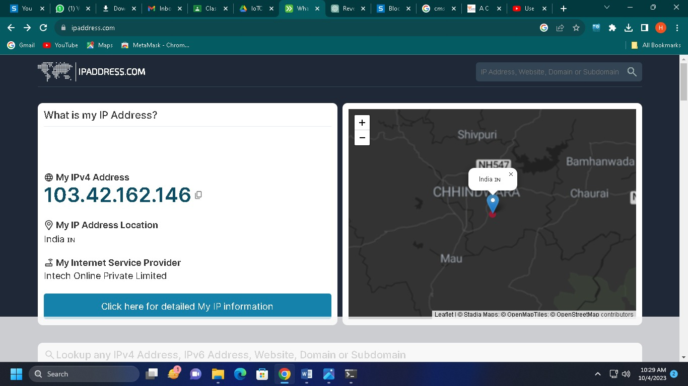

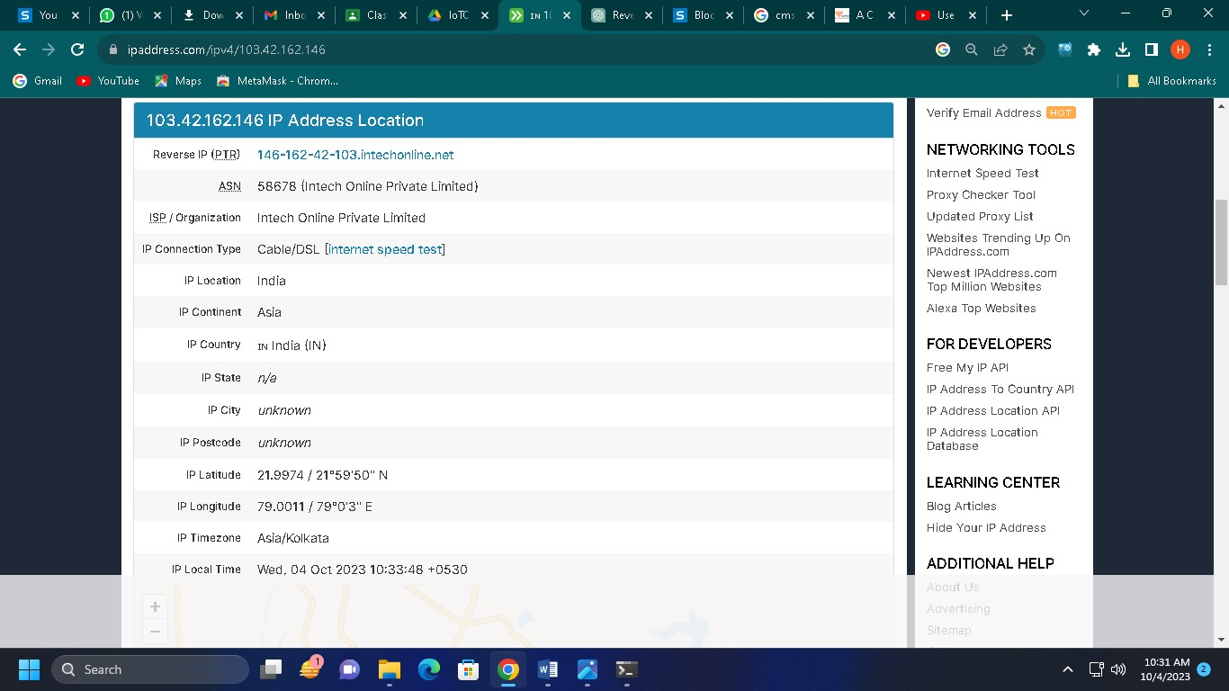

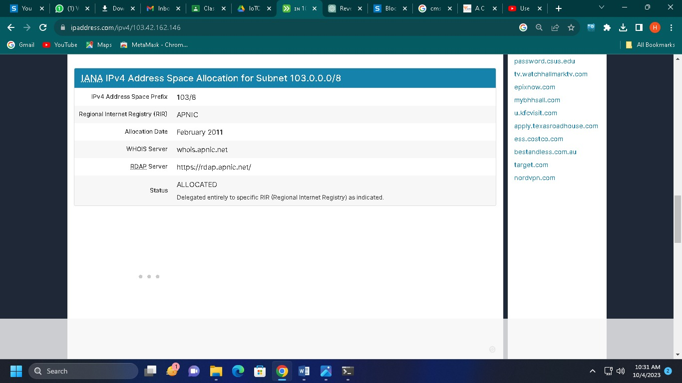

**Conclusion:**

We have successfully used the geolocation (country, city, or approximate location) of each IP address (at least 10) One can use online IP geolocation tools, databases, and various techniques to gather information and accurately identify the physical location associated with each IP.

**EXPERMINT: 09**

⚫ **Aim:** Conduct a comprehensive OSINT investigation about well-known company and gather information about the company's history, key executives, financial data, partnerships, news mentions, and any other relevant details using online databases, news articles, corporate websites, and industry reports.

⚫ **Theory:**

Conducting a comprehensive OSINT (Open-Source Intelligence) investigation about a well-known company typically involves gathering information from various sources such as online databases, news articles, corporate websites, industry reports, and more. Below, I'll suggest some OSINT tools and methods you can use to gather different types of information:

**1. Company History:**

* **Corporate Website:** Start with the official website of the company. Look for an "About Us" or "History" section that provides details about the company's founding, growth, and milestones.

**2. Key Executives:**

* **LinkedIn:** LinkedIn is a valuable resource for finding information about key executives. Search for the company's LinkedIn page or individual executive profiles.

**3. Financial Data:**

* **SEC EDGAR Database:** The U.S. Securities and Exchange Commission's EDGAR database provides access to financial filings and reports of publicly traded companies in the United States.
* **Financial News Websites:** Websites like Bloomberg, Reuters, Yahoo Finance, or Google Finance often provide financial data and news related to companies.

**4. Partnerships:**

* **Company Press Releases:** Check the company's press release section on their website for announcements of partnerships and collaborations.
* **News Articles:** Search for news articles or press releases about the company's partnerships using search engines or news aggregators.

**5. News Mentions:**

* **Google News:** Use Google News to search for recent news articles mentioning the company.
* **Media Monitoring Tools:** Tools like Google Alerts, Mention, or Brandwatch can help you set up alerts for news mentions related to the company.

**6. Industry Reports:**

* **Market Research Firms:** Access industry reports and market analysis from reputable market research firms like Gartner, Forrester, or Statista.

**7. Online Databases:**

* **Hoovers:** Hoover's offers company information, including financials, executives, and industry analysis.
* **Crunchbase:** Crunchbase provides information about companies, their funding, key personnel, and partnerships.
* **Bloomberg Terminal (for professionals):** Bloomberg Terminal offers extensive financial and market data for in-depth research.

**8. Social Media:**

* **Twitter:** Check the company's official Twitter account for recent updates and announcements.
* **Facebook and Instagram:** Some companies also share news and updates on these platforms.

Remember to evaluate the credibility and reliability of your sources, especially when it comes to financial data and news. Multiple sources should corroborate information, and you should cross-reference details from different sources to ensure accuracy.

Additionally, be respectful of privacy and legal considerations when conducting OSINT investigations, especially when dealing with personal information and financial data. Always adhere to ethical guidelines and applicable laws.



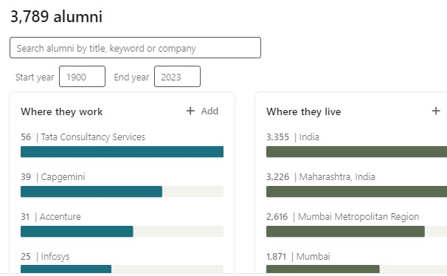



⚫ **Conclusion:**

We have successfully conducted a comprehensive OSINT investigation about well-known company and gather information about the company's history, key executives, financial data, partnerships, news mentions, and any other relevant detailsusing online databases, news articles, corporate websites, and industry reports.

**EXPERMINT: 10**

⚫ **Aim:** Analyze the company's competitors to understand their market positioning, strengths, and weaknesses. Tools like SEMrush, Similar Web, or Alexa or any other OSINT tool can provide website traffic, keyword analysis, and competitor comparisons.

⚫ **Theory:**

SEMrush is not an open-source intelligence (OSINT) tool. SEMrush is a popular and widely used online marketing and SEO (Search Engine Optimization) tool that is primarily focused on competitive analysis, keyword research, and SEO optimization. It provides a variety of features and tools to help businesses and digital marketers improve their online presence and visibility. Some of the key features of SEMrush include:

1. **Keyword Research:** SEMrush helps users identify valuable keywords for their websites and track keyword rankings. It provides information about keyword search volume, competition, and trends.
2. **Competitive Analysis:** Users can analyze their competitors' websites and online strategies, including their organic search rankings, paid advertising campaigns, and backlink profiles.
3. **Site Audit:** SEMrush offers a site audit feature that helps users identify technical issues on their websites that may affect SEO performance. It provides recommendations for improving website health.
4. **Backlink Analysis:** Users can analyze backlinks to their own websites and their competitors' sites. This can help with link-building strategies and identifying potentially harmful backlinks.
5. **Advertising Research:** SEMrush provides data on paid advertising campaigns, including ad keywords, ad copies, and ad spend of competitors. This can be useful for creating effective PPC (Pay-Per-Click) campaigns.
6. **Content Analysis:** SEMrush helps users analyze the content on their websites and suggests improvements to optimize for SEO. It can also provide ideas for content creation.
7. **Social Media Analysis:** Users can monitor their social media performance and track competitors' social media activity.

While SEMrush is a valuable tool for digital marketers and website owners, it is not an OSINT tool. OSINT tools are typically used for gathering information from publicly available sources on the internet, and they serve various purposes, including cybersecurity, investigations, and threat intelligence.

If you are looking for OSINT tools, there are many specialized tools and resources available for different OSINT purposes, such as investigating individuals or organizations, gathering intelligence on social media, or monitoring online threats. Some popular OSINT tools include Maltego, Shodan, SpiderFoot, and various social media analysis tools. These tools are designed to collect and analyze publicly available information to support investigations and research.

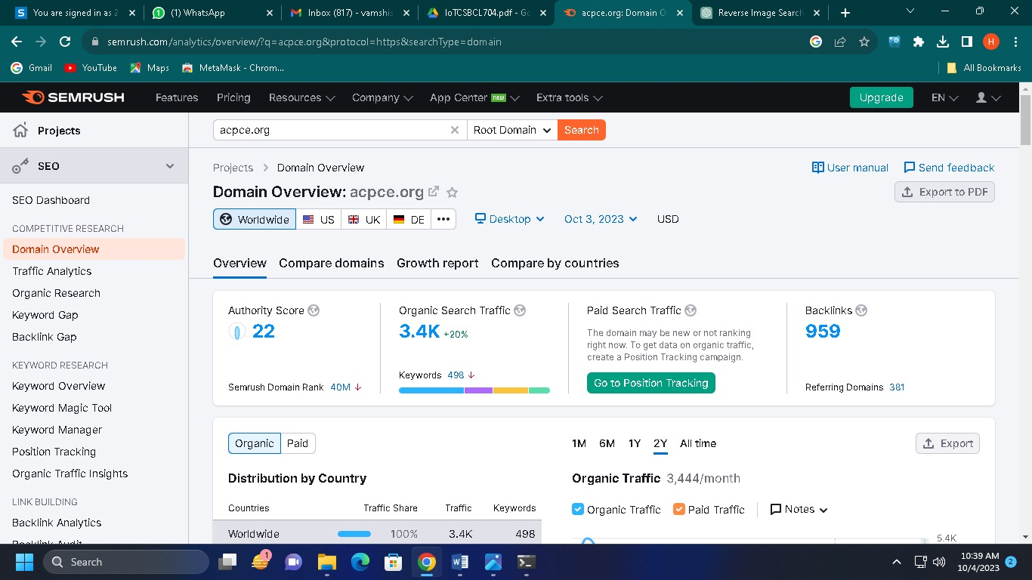

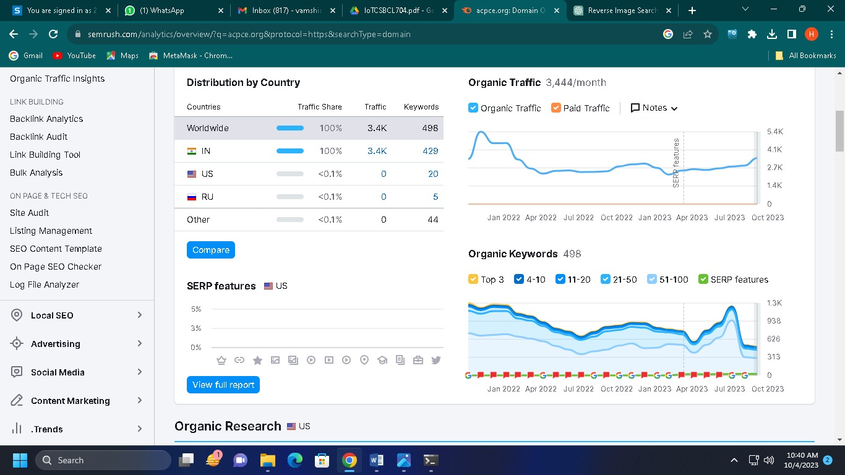

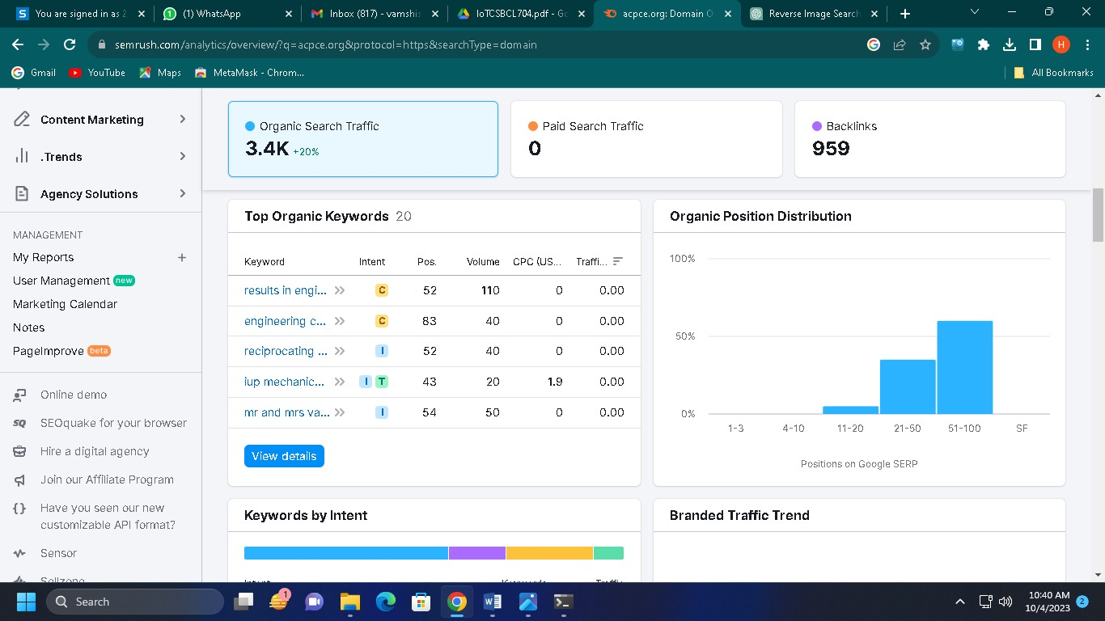

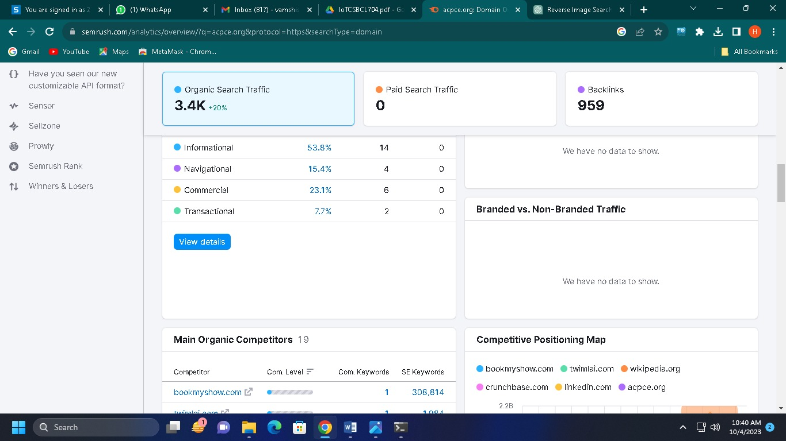

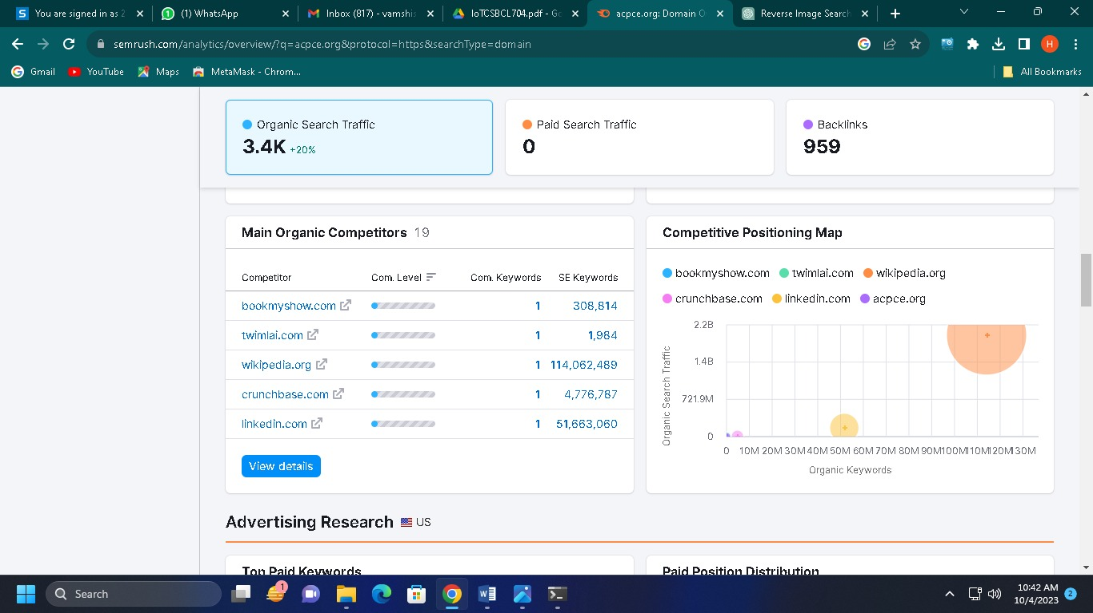

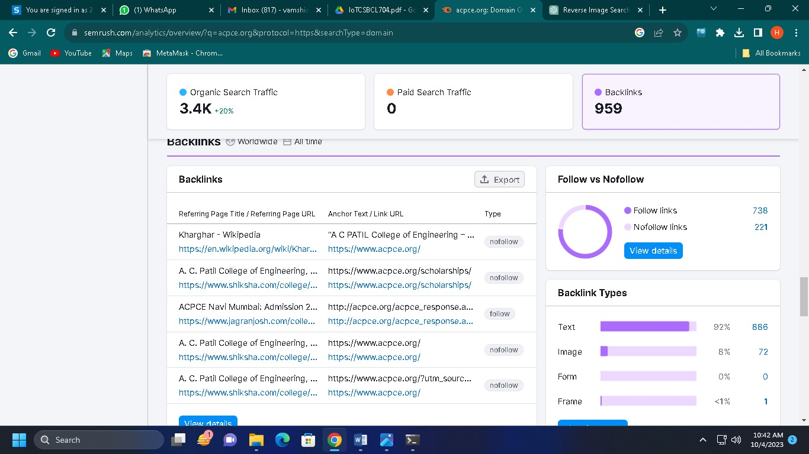

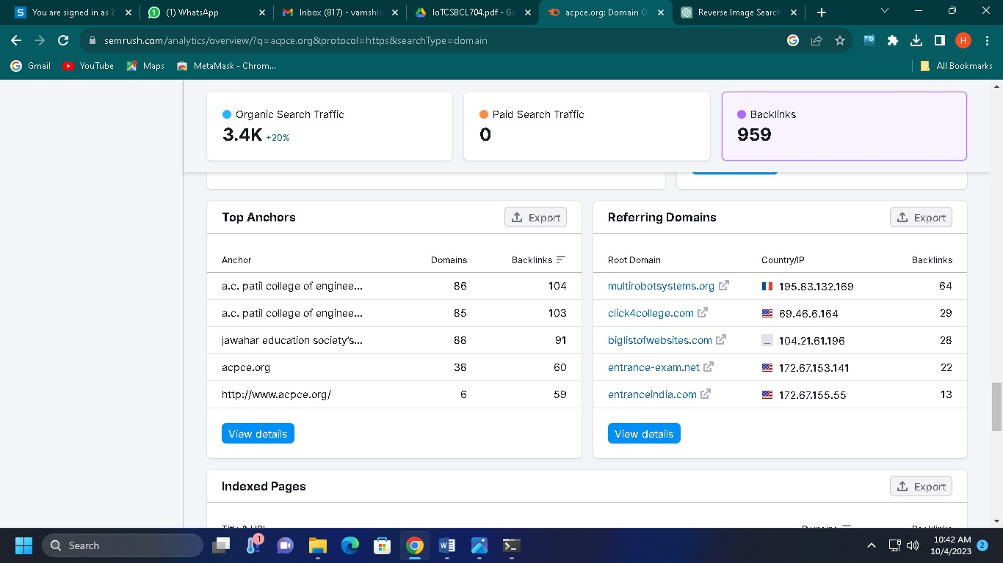

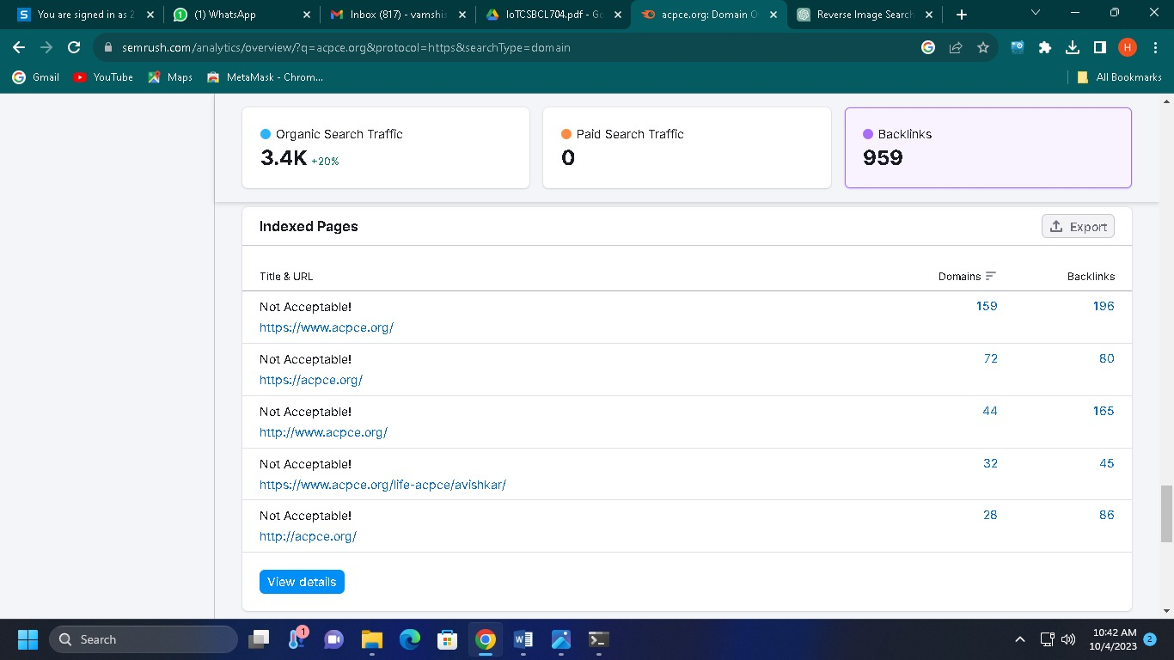

Top of Form

SimilarWeb is not an open-source intelligence (OSINT) tool. SimilarWeb is a commercial web analytics platform that provides insights and data about websites and mobile apps. Its primary purpose is to help businesses and digital marketers understand web traffic, audience demographics, and the online behavior of websites and apps.

Key features of SimilarWeb include:

1. **Website Traffic Analysis:** SimilarWeb provides data on website traffic, including total visits, unique visitors, pageviews, and engagement metrics. It also offers information on traffic sources, such as organic search, paid search, referral traffic, and social media.
2. **Audience Demographics:** Users can access demographic data about a website's audience, including age, gender, location, and interests. This information can be valuable for targeting specific user groups.
3. **Competitor Analysis:** SimilarWeb allows users to compare the performance of their website or app with competitors. This includes traffic rankings, audience overlap, and keyword analysis.
4. **Keyword Analysis:** SimilarWeb provides data on the keywords that drive traffic to a website. This can be useful for SEO and content strategy.
5. **Mobile App Insights:** The platform offers insights into the performance of mobile apps, including download statistics, user ratings, and competitor comparisons.
6. **Industry Benchmarks:** Users can access industry-specific benchmarks to see how their website or app compares to others in the same industry.

While SimilarWeb is a valuable tool for businesses and marketers to gain insights into online performance and competition, it is not an OSINT tool. OSINT tools are typically used for gathering and analyzing publicly available information from various online sources for investigative, research, or security purposes.

If you are specifically looking for OSINT tools, you may want to explore other tools and resources that are designed for tasks such as collecting information from social media, tracking online mentions, or conducting online investigations. Some popular OSINT tools for these purposes include Maltego, OSINT Framework, and tools for social media analysis like Twint and Scrapy. These tools are more focused on open-source intelligence gathering and analysis.

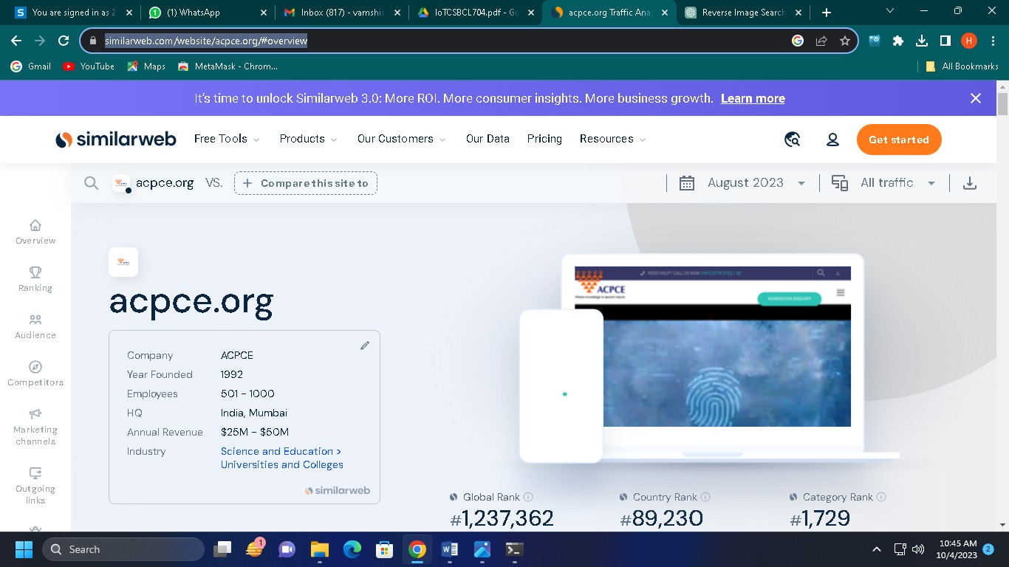

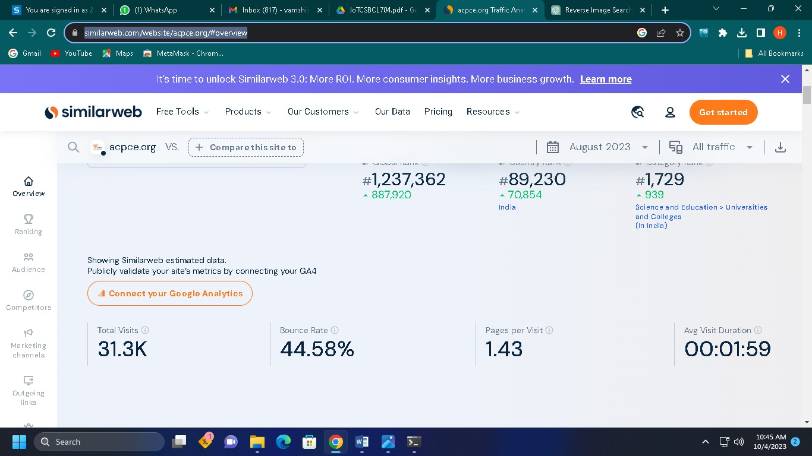

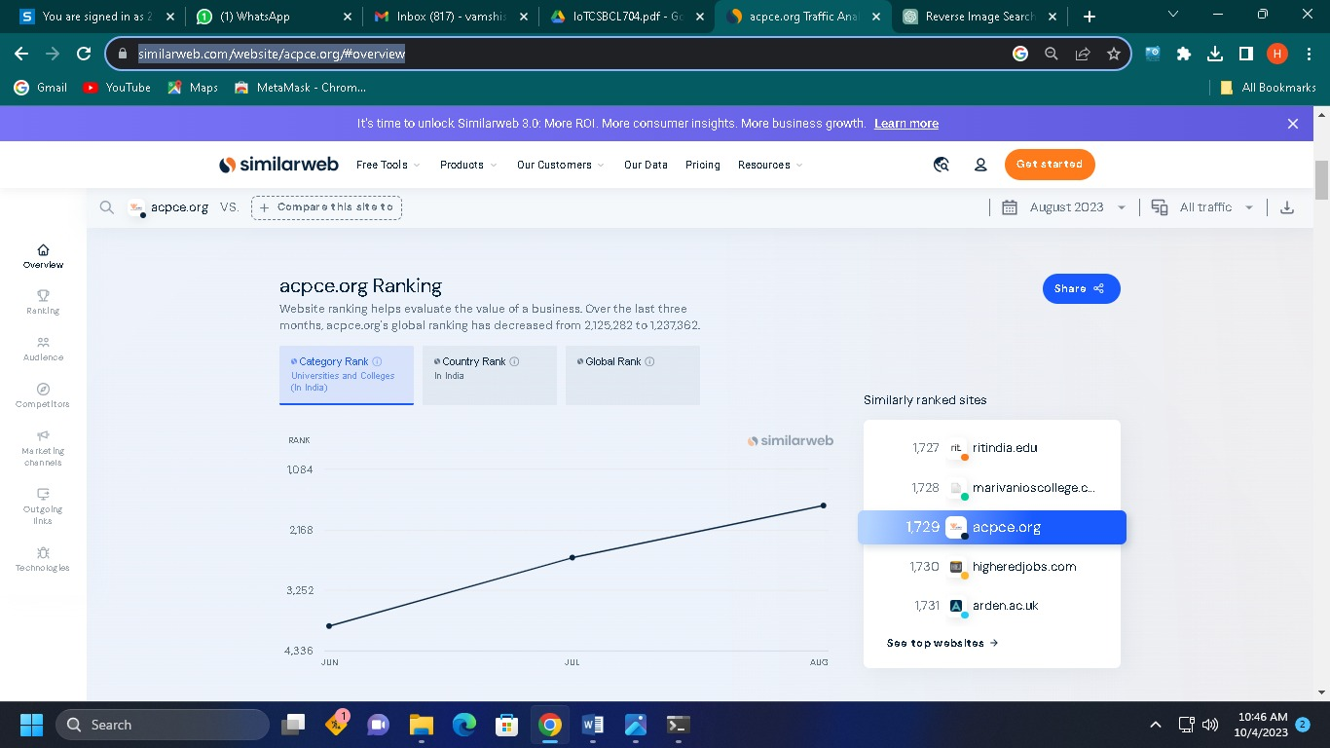

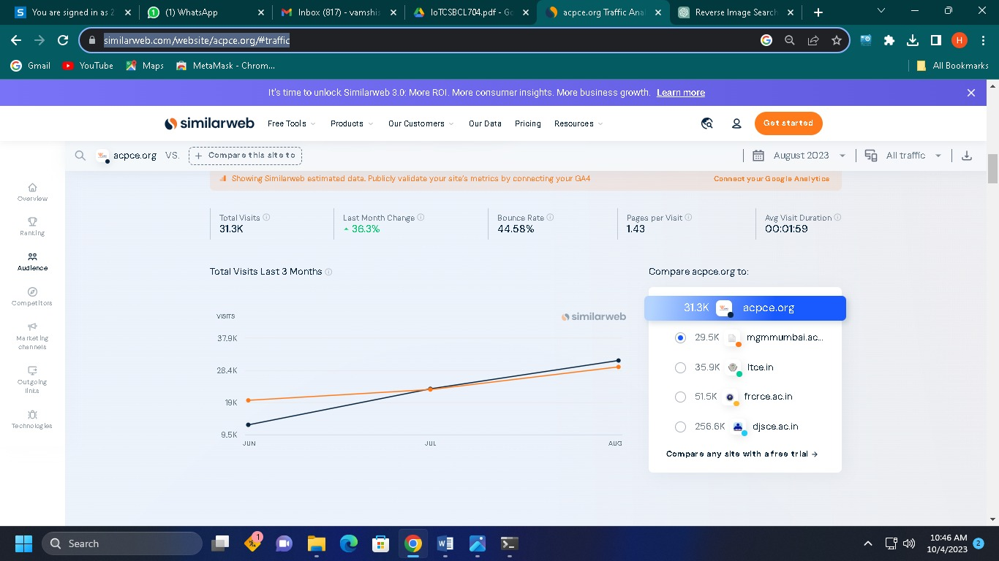

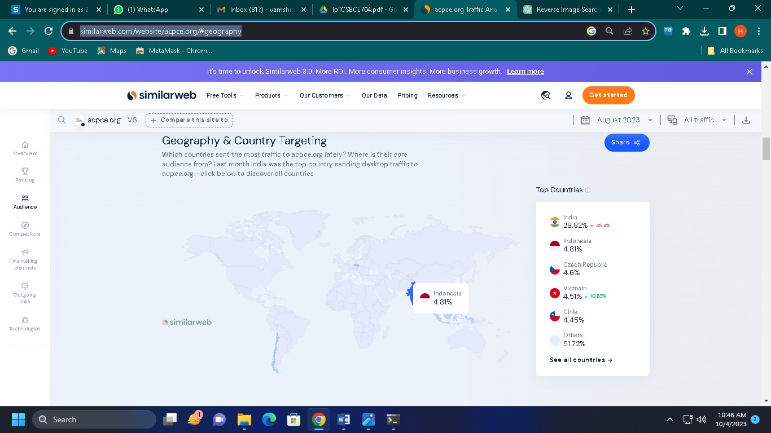

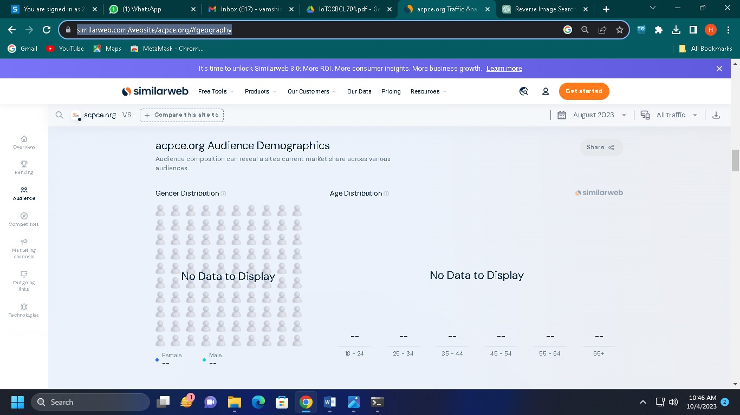

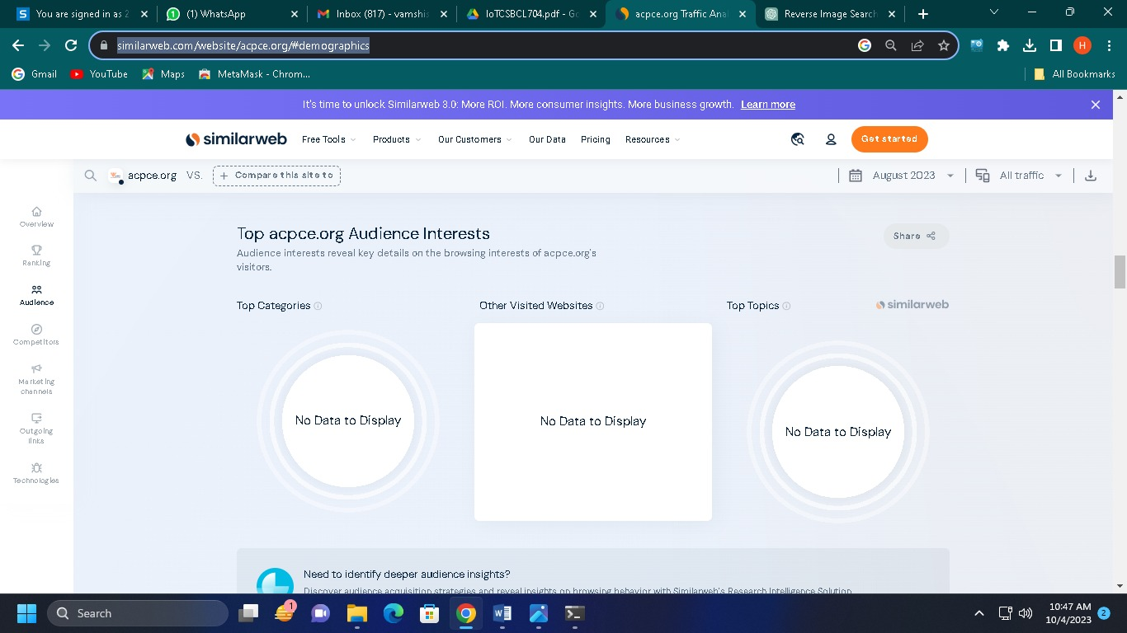

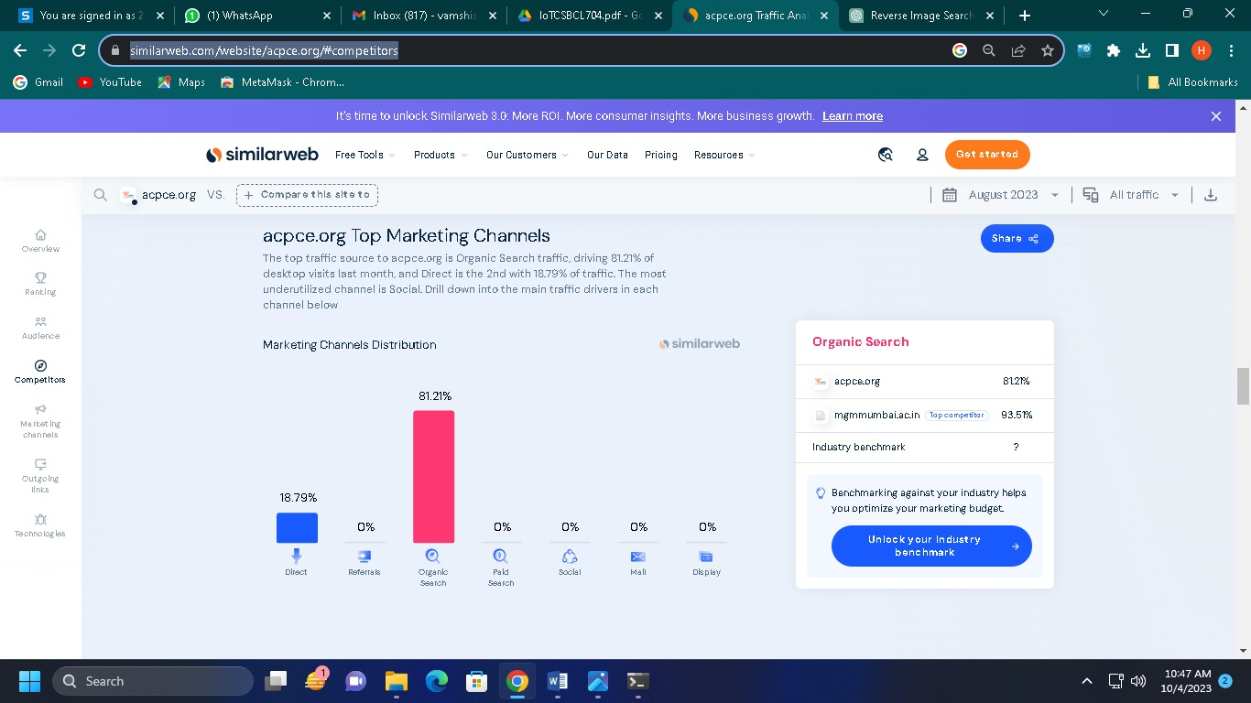

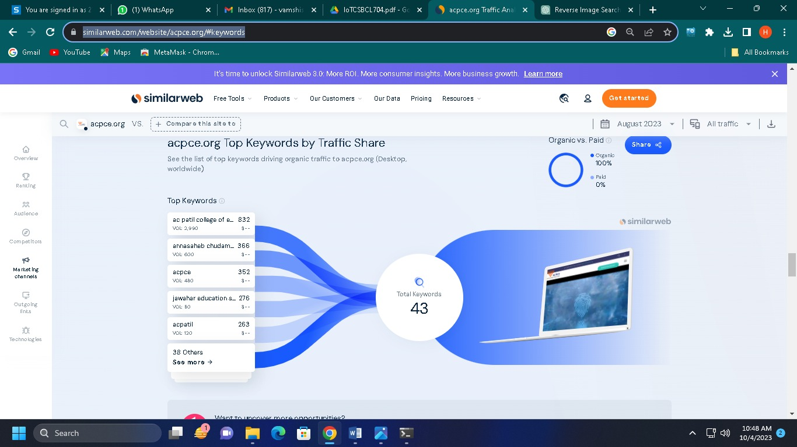

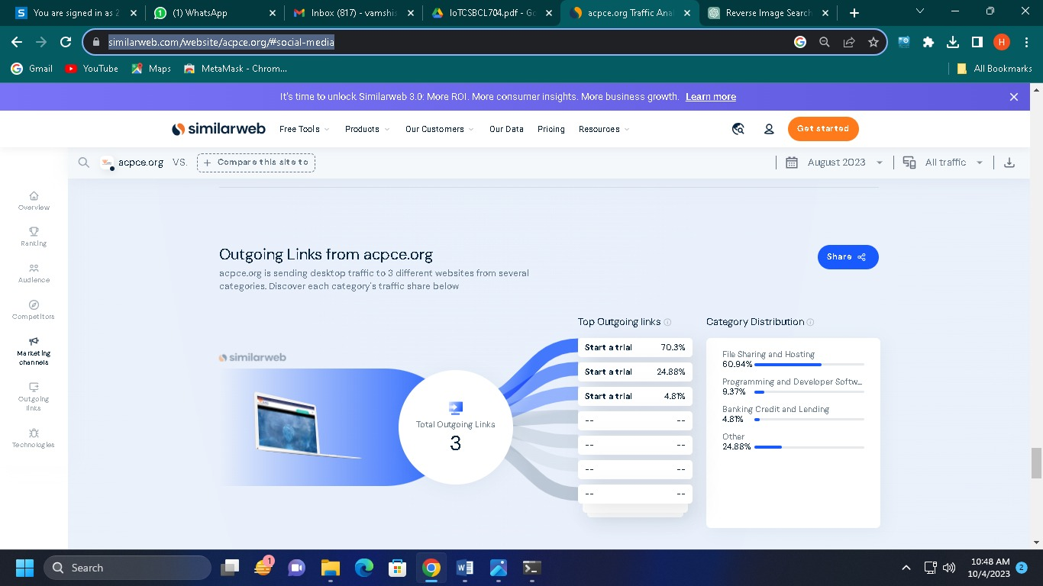

⚫ **Conclusion:**

We have successfully used Analyze the company's competitors to understand their market positioning, strengths, and weaknesses. Tools likeSEMrush, Similar Web, or Alexa or any other OSINT tool can provide website traffic, keyword analysis, andcompetitor comparisons.

**EXPERMINT: 11**

⚫ **Aim:** Fake News detection - Analyze at least 5 OSINT tools to detect, verify, authenticate, fake news and report.

⚫ **Theory:**

Detecting fake news is a challenging but important task in today's digital age. Fake news can spread rapidly and have real-world consequences. Here are some approaches and tools that can be used to detect fake news:

1. **Fact-Checking Websites:** Fact-checking websites like Snopes, PolitiFact, FactCheck.org, and others regularly investigate and verify the accuracy of news stories. You can cross-check the information against these sources.
2. **News Aggregator Platforms:** Platforms like Google News and Bing News often aggregate news from multiple sources. By comparing the same story from different reputable sources, you can get a sense of its credibility.
3. **Reverse Image Search:** Fake news stories often include manipulated or misleading images. You can use reverse image search engines like Google Images or TinEye to check the authenticity of images in a news story.

The fake news detection is not always straightforward, and even reputable sources can make mistakes. Therefore, it's crucial to be vigilant and use a combination of tools and critical thinking skills to assess the credibility of news stories before accepting them as true.

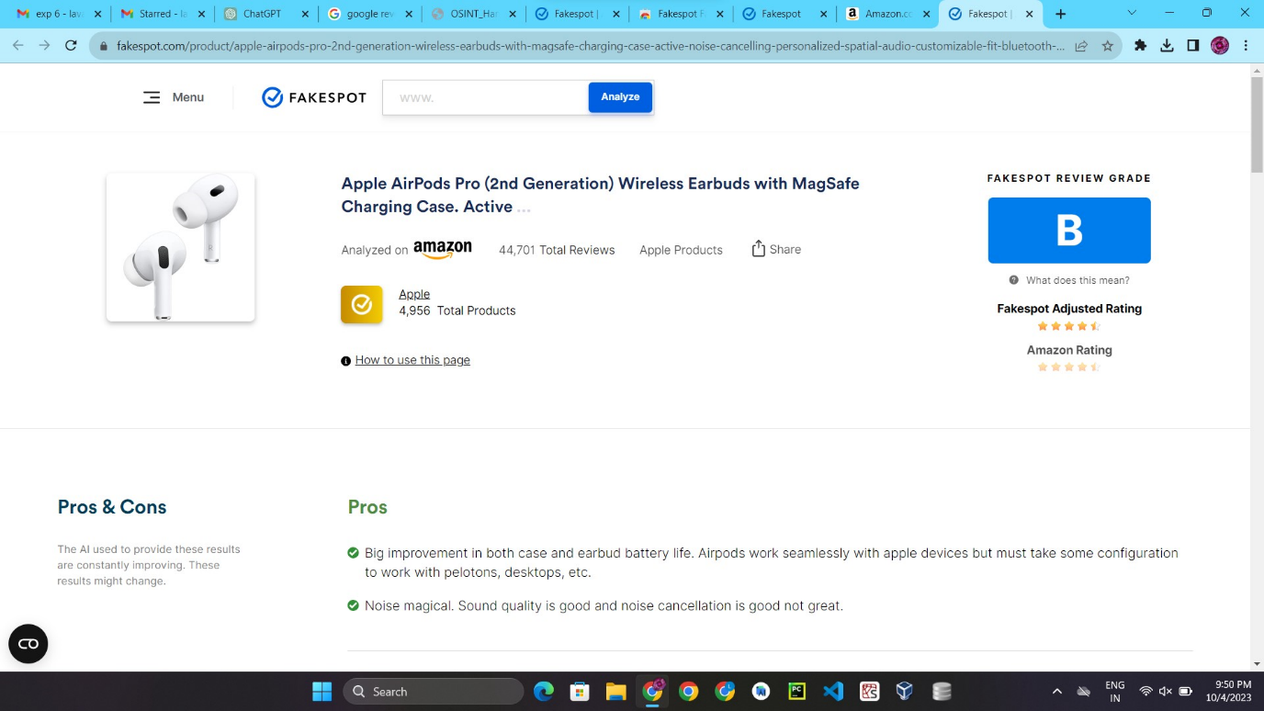



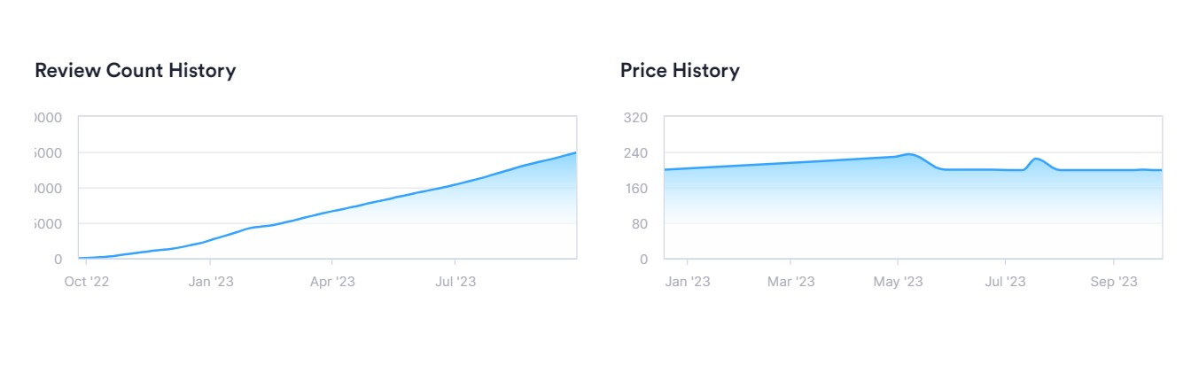

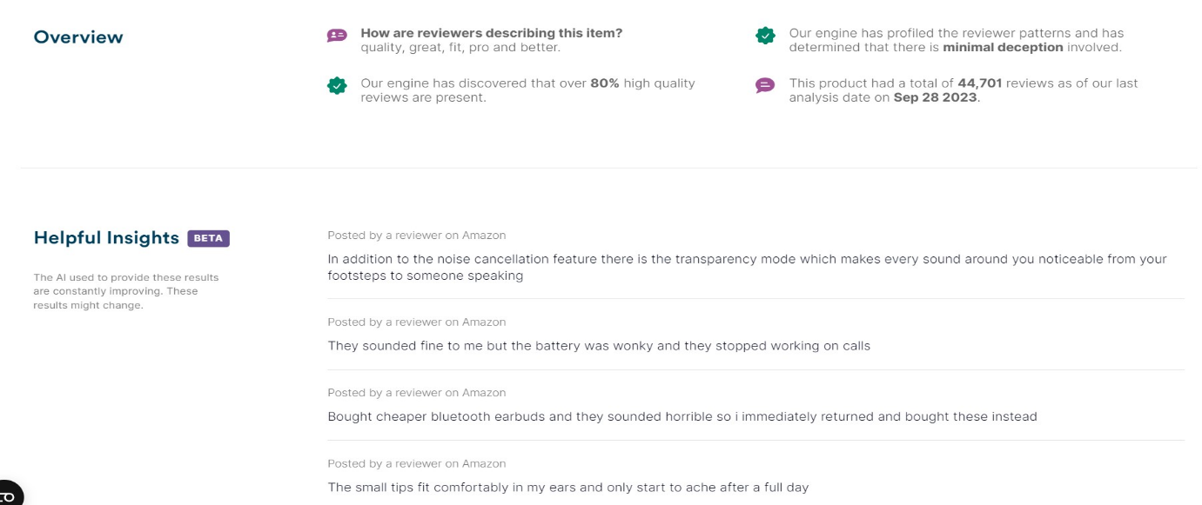

⚫ **Conclusion:**

We have successfully used fake News detection - Analyze at least 5 OSINT tools to detect, verify, authenticate, fake news and report.

**EXPERMINT: 12**

⚫ **Aim:** Utilize website crawling OSINT tools to gather a comprehensive list of URLs, internal links, and structure of the website.

⚫ **Theory:**

A hotel management system web application is a comprehensive process that involves several stages, from defining the project scope and requirements to designing the system architecture, developing the software, testing, and finally deploying it. Below is a detailed project plan for creating a hotel management system web application:

**Project Initiation:**

* Define Project Objectives:
  + Clearly state the goals and objectives of the hotel management system.
* Identify Stakeholders:
  + Determine who will be involved in the project and their roles.
* Budget and Resources:
  + Allocate a budget and identify the necessary resources, including personnel, software, and hardware.
* Project Team Formation:
  + Assemble a project team with the required skills and expertise.

**Requirements Gathering:**

* Conduct Stakeholder Interviews:
  + Meet with hotel staff, management, and potential users to gather detailed requirements.
* Create a Requirements Document:
  + Document functional and non-functional requirements.
* Prioritize Requirements:
  + Determine which features are essential for the initial release and which can be added later.

**System Design:**

* System Architecture:
  + Design the overall system architecture, including the database schema, server infrastructure, and front-end components.
* User Interface Design:
  + Create wireframes and prototypes for the user interface.
* Database Design:
  + Design the database structure, tables, and relationships.
* Security Design:
  + Plan for user authentication, authorization, and data encryption.

**Development:**

* Backend Development:
  + Develop the server-side logic and APIs for handling hotel data, reservations, payments, etc.
* Frontend Development:
  + Implement the user interface based on the design.
* Database Implementation:
  + Create and populate the database with sample data for testing.
* Integration:
  + Integrate third-party services (e.g., payment gateways, mapping APIs) if required.
* Quality Assurance:
  + Conduct ongoing testing throughout the development process.

**Testing:**

* Unit Testing:
  + Test individual components and functions.
* Integration Testing:
  + Test how different parts of the system work together.
* User Acceptance Testing (UAT):
  + Involve end-users to validate the system's functionality.
* Performance Testing:
  + Ensure the system can handle expected load and traffic.
* Security Testing:
  + Test for vulnerabilities and apply security best practices.

**Deployment:**

* Server Setup:
  + Configure production servers, databases, and environments.
* Data Migration:
  + Move the database from development to production.
* Deployment of Code:
  + Deploy the application to production servers.
* Monitoring and Maintenance:
  + Set up monitoring tools and establish a maintenance plan.

**Training and Documentation:**

* Provide training for hotel staff on how to use the system.
* Create user manuals and documentation for future reference.

**User Support and Feedback:**

* Establish a system for receiving and addressing user feedback and issues.
* Plan for future updates and improvements based on feedback.

**Marketing and Launch:**

* Develop a marketing plan to promote the new system.
* Launch the system to the public or within the hotel.

**Post-Launch Evaluation:**

* Monitor system performance and user satisfaction.
* Make necessary improvements and updates based on feedback and usage data.

**Maintenance and Ongoing Development:**

* Regularly maintain and update the system to address bugs, security issues, and evolving business needs.
* Continue developing new features and enhancements.

**Project Closure:**

* Conduct a project review to assess its success against initial objectives.
* Document lessons learned for future projects.
* Close out the project and hand over responsibilities to relevant stakeholders.

That this is a general project plan, and the specifics may vary depending on the scale and complexity of your hotel management system web application project. Additionally, consider using project management tools and methodologies (e.g., Agile, Scrum) to help manage the project effectively.

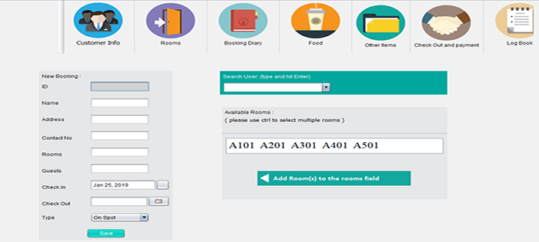Top of Form

⚫ **Conclusion:**

In conclusion, developing a hotel management system web application is a complex and multifaceted endeavor that requires meticulous planning and execution. This project plan outlines the various stages and key tasks involved in the development process.

**EXPERMINT: 07**

⚫ **Aim:** Use OSINT Tools to identify the technologies and frameworks used by the website, such as content management systems (CMS), server software, programming languages, or analytics tools and create vulnerability reports.

⚫ **Theory:**

**Theory:**

There are many OSINT tools to identify the technologies and frameworks used by the website, such as content management systems (CMS), server software, programming languages.

One of them is WHATRUNS. "WhatRuns" is a browser extension designed to help users quickly identify the technologies and frameworks used by websites they visit.



When you visit a website, you can activate the WhatRuns extension by clicking on its icon in your browser's toolbar. Once activated, the extension will scan the webpage and provide a list of technologies and tools that the website is using.

WhatRuns provides detailed information about various aspects of a website's technology stack, including:

* Content Management System (CMS) if applicable (e.g., WordPress, Joomla, Drupal).
* Web server software (e.g., Apache, Nginx).
* JavaScript libraries and frameworks (e.g., jQuery, React, Angular).
* Fonts and typography used on the site.
* Analytics and tracking tools (e.g., Google Analytics).
* CDN (Content Delivery Network) services.
* Advertising and marketing platforms.



⚫ **Conclusion:**

We have successfully used OSINT Tools to identify the technologies and frameworks used by the website, such as content management systems (CMS), server software, programming languages, or analytics tools and create vulnerability reports.

**Viva Questions**

**Define osnit :**

“Open Source Intelligence (OSINT) is information that is legally gathered from public sources. This information can be used to provide actionable insights for decision-makers.”

**OSINT can come from:**

* Public online sources
* Offline resources
* Books, magazines, and newspapers
* Public government data, reports, budgets, hearings, telephone directories, press conferences, websites, and speeches

OSINT is a process that involves: Identifying data, Harvesting data, Processing data, Analyzing data, Reporting data.

**OSINT can be used by:**

* Security experts
* National intelligence agencies
* Cybercriminals

**OSINT can be used to:**

* Understand what information you are giving to potential attackers
* Passively acquire intelligence without alerting the target.

**key benefits of OSINT include**:

Cost-Effective: OSINT typically relies on publicly accessible data and open-source tools, making it a cost-effective method of information gathering compared to other intelligence-gathering methods.

Widespread Data Sources: OSINT draws information from a broad range of publicly available sources, including the internet, social media, government records, academic publications, news sources, and more.

Timeliness: OSINT allows for real-time or near-real-time data collection, making it suitable for monitoring and staying up-to-date on events, trends, or emerging threats.

Versatility: OSINT can be applied to various domains, including national security, law enforcement, corporate intelligence, competitive analysis, cybersecurity, and journalism.

Enhanced Decision-Making: The data gathered through OSINT can help organizations and individuals make informed decisions, assess risks, and identify opportunities.

Security and Threat Analysis: OSINT plays a crucial role in threat intelligence and security assessments, helping organizations detect and mitigate potential risks and vulnerabilities.

Competitive Intelligence: In the business world, OSINT can be used to gather information about competitors, market trends, consumer sentiment, and emerging technologies.

Investigative Tools: OSINT aids in investigations by providing background information on individuals, organizations, or events, helping law enforcement and private investigators.

Reputation Management: Businesses and individuals can use OSINT to monitor their online reputation and respond to potential issues or threats.

Research and Analysis: OSINT supports academic research and analysis by providing access to a vast pool of publicly available data.

**Online threats**

Online threats are cybersecurity risks that can cause undesirable events or actions via the internet. They can be made possible by:

* End-user vulnerabilities
* Web service developers/operators
* Web services themselves

Some examples of online threats include:

* Trojan horse
* Worms
* Viruses
* Spyware
* Phishing

OSINT Type

* Web-Based OSINT:
* Government and Public Records:
* Academic and Research Sources:
* Human Intelligence (HUMINT):

**Search Techniques**

* Broad and narrow searches.
* Search blocks.
* Combining search words with Boolean operators (AND, OR and NOT)
* Searching for part of words (truncation)
* Searching for phrases (quotation marks)
* Simple and advanced search forms.
* Improving your search

**Metasearch**

A metasearch engine (or search aggregator) is an online information retrieval tool that uses the data of a web search engine to produce its own results.

**Automated** **Online** Search Tool is an application that can be configured to automatically gather information from a specified number of Internet-based sources. Examples include Google Alerts, Yotify, Alerts.com, Twitter, and WatchThatPage.

**NEWS SERACH**

News search is the process of using search engines or specialized news search engines to find current news articles, reports, and information on specific topics or events. News search is a valuable tool for staying informed about the latest developments, trends, and events across various domains.

**OSINT techniques include:**

* Search engines, such as Google, Bing, and Yahoo
* Passive collection, which involves scraping publicly available websites, retrieving data from open APIs, or pulling data from deep web information sources

**OSINT can be useful for:**

* Searching global news for situational awareness
* Debunking fake news

**Some OSINT tools include:**

* Search engines, such as Google, Bing, and Yahoo
* Open APIs, such as the Twitter API
* VPN services, such as NordVPN and Private Internet Access.

**Harvester**

The Harvester is a tool that can be used by penetration testers to gather information from public sources. It's pre-installed in Kali Linux.

The Harvester uses public sources like:

* Search engines
* PGP key servers
* SHODAN computer database

The Harvester can gather information like:

Emails, Subdomains, Hosts, Employee names, Open ports, Banners.

The Harvester is a command-line tool that acts as a wrapper for search engines. It's intended to help penetration testers in the early stages of a penetration test.

**Reverse image**

Reverse image analysis, also known as reverse image search, is a technique used to find information about an image by searching for it based on the image's content rather than text-based queries.

**TinEye**

Open Source Intelligence (OSINT) tools can assist in identifying and verifying the authenticity of news and information.

**FAKE NEWS DEECTION TOOL:**

1. **Google Reverse Image Search**: Verify the authenticity of images used in news stories by performing a reverse image search on Google Images. This can help you determine if an image has been used in a misleading or unrelated context.
2. **TinEye**: TinEye is a dedicated reverse image search tool that can help you find the original sources of images or track their usage across the internet.
3. **Fact-Checking Websites**: Websites like Snopes, FactCheck.org, and PolitiFact are dedicated to fact-checking news stories and debunking false claims.

Analyzing a digital footprint using OSINT (Open Source Intelligence) tools involves the systematic collection of publicly available information about an individual, organization, or entity from various online sources

Semrush the best tool?

It ranked as one of Forbes Advisor's best SEO software. In addition to its comprehensive keyword research tool, it also offers a wide range of SEO-related tools such as rank tracking, website monetization, competitor SEO analysis, content optimization, social media management, local SEO and more.

What is geolocation tracking?

Geolocation refers to the identification of the geographic location of a user or computing device via a variety of data collection mechanisms.

Geolocation is **the process of using technology to identify the location of an object or person**. It can be used to track the movements and location of people, and for surveillance.

**Geolocation uses various methods, including:**

* GPS
* IP addresses
* Wi-Fi positioning

Footprinting is **an ethical hacking technique that involves gathering information about a targeted computer system, infrastructure, and networks**. The goal of footprinting is to identify opportunities to penetrate the system and find vulnerabilities.